**PROJECT 2: SINGLE SOURCE SHORTEST PATH TESTING (Part 3)**

Noah Hendlish CMPS 2200

Friday, December 8, 2017 Introduction to Algorithms

**EXTRA CREDIT CONSIDERATION:**

**(1) User Interface (UI) to make program user friendly (interactive with console)**

**(2) Ability to choose source as any given vertex in the graph when running Shortest Path Algorithms**

**(3) Manipulation of GUI to make it more user friendly/clear**

**INSTRUCTIONS**: Test your entire code (all parts) using an appropriate set of input graphs, and write a short report that documents your *tests. Please add screen shots to the report. For your tests, use at least the graph data files provided with the project.* Run **Dijkstra** and **Bellman**-**Ford** on the same inputs and compare the outputs. What happens in the case of **negative weights** or **negative weight cycles**?

**OVERVIEW OF PROJECT AND UI**

For my project, I decided to implement a user friendly aspect/ a UI (User interface through the console). Once my project begins to run, it prompts the user to enter either the graph file name or the graph file’s corresponding number from the following list (“graph selection menu”):

Graph Selection Menu

Graph # Graph Type Graph Filename

1 Non-Negative Weight Directed Graph graph.dat

2 Negative Weight Directed Graph graphNeg.dat

3 Negative Cycle Directed Graph graphNegCycle.dat

4 Undirected Graph graphUndirected.dat

5 Test Graph 1 test1.dat

6 Test Graph 2 test2.dat

If the input is NOT an integer between 1 and 6 OR the input does not correspond to a graph’s file name, the UI will ask for a VALID input and repeatedly prompt the user to enter a valid input until one is entered.

Once an initial graph is loaded, the graph will display in a separate window (GUI).

Then the console will print the following menu:

Graph Action Menu

Type the corresponding Number to preform actions on the graph:

1. Select New Graph File

2. Run Bellman-Ford's Shortest Path Algorithm on Graph

3. Run Djikstra's Shortest Path Algorithm on Graph

4. Print Graph's info (adjacency list and edges)

5. Quit

The console prompts the user to enter a” corresponding number to preform actions on the graph”. To load an entirely new graph file, the user enters 1. If the user enters either 2 or 3: the program runs a single shortest path algorithm (displaying the d-values, edges, and source in the GUI & printing the according predecessor array and array of all vertices d-values in the console). To run Bellman-Ford on the Graph, the user must enter 2 and to run Dijkstra, the user must enter 3. If the user wants to simply print the graphs information (the adjacency list of the graph, displaying all the vertices (including their ID, x and y plot values in the GUI, and then each vertex’s corresponding adjacent vertices (and their ID and x and y values, and the weight of the edge from the vertex and its corresponding adjacent vertex), the user must enter 4. When the user wants to quit the program, they must enter 5. When the program quits, the terminal will no longer ask for input and the GUI/ window will close.

**EXPLANATION AND ANALYSIS OF SHORTEST PATH ALGORITHMS ON GRAPHS**

***\*****lists****/****explanations are very similar to output in console and references data from console.*

**Dijkstra’s Algorithm on graph.dat (Non-Negative Weight Directed Graph)**

**Source Vertex’s ID: 0**

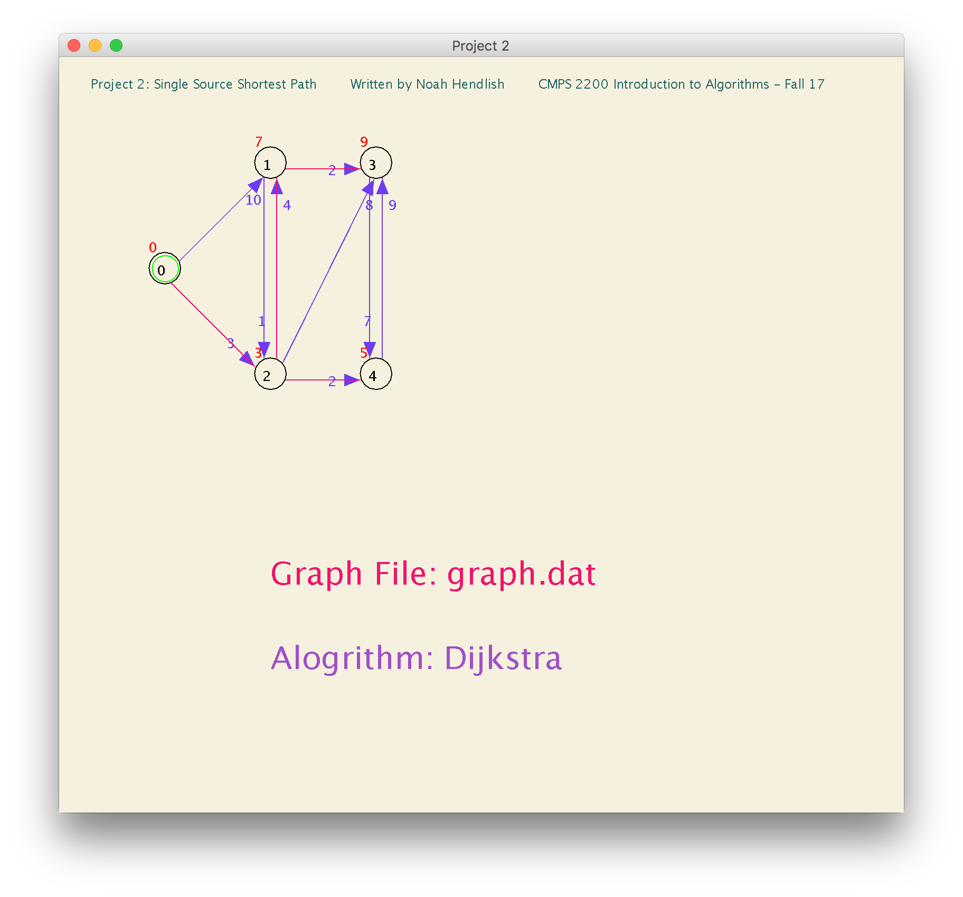

Graph does not contain any negatively weighted edges. All Edge weights positive. Dijkstra can find the shortest path.

**d-Values for Dijkstra on graph.dat**

*(d-Value of 0 means vertex is source, d-value of null means vertex has infinity/max d-value. If Vertex's d-value is null (e.g. it has infinity/max-devalue), it was not traversed since it is inaccessible from source)

**Vertex: 0 1 2 3 4**

**d-Value: 0 7 3 9 5**

**Predecessor Array for Dijkstra on graph.dat**

*(Predecessor ID / Value of -1 means vertex has no predecessor, e.g., the source vertex has predecessor of -1. Non-source vertex with -1 predecessor ID was not traversed since it is inaccessible from source)

**Vertex: 0 1 2 3 4**

**Predecessor: -1 2 0 1 2**

Even though the two algorithms run on different conditions (i.e. handling negative/positive weights), their overall objective is the same, on any positively weight (NON-NEGATIVE) graph, Djikstra and Bellman Ford should have the same output.

**Bellman-Ford on graph.dat (Non-Negative Weight Directed Graph)**

**Source Vertex ID: 0**

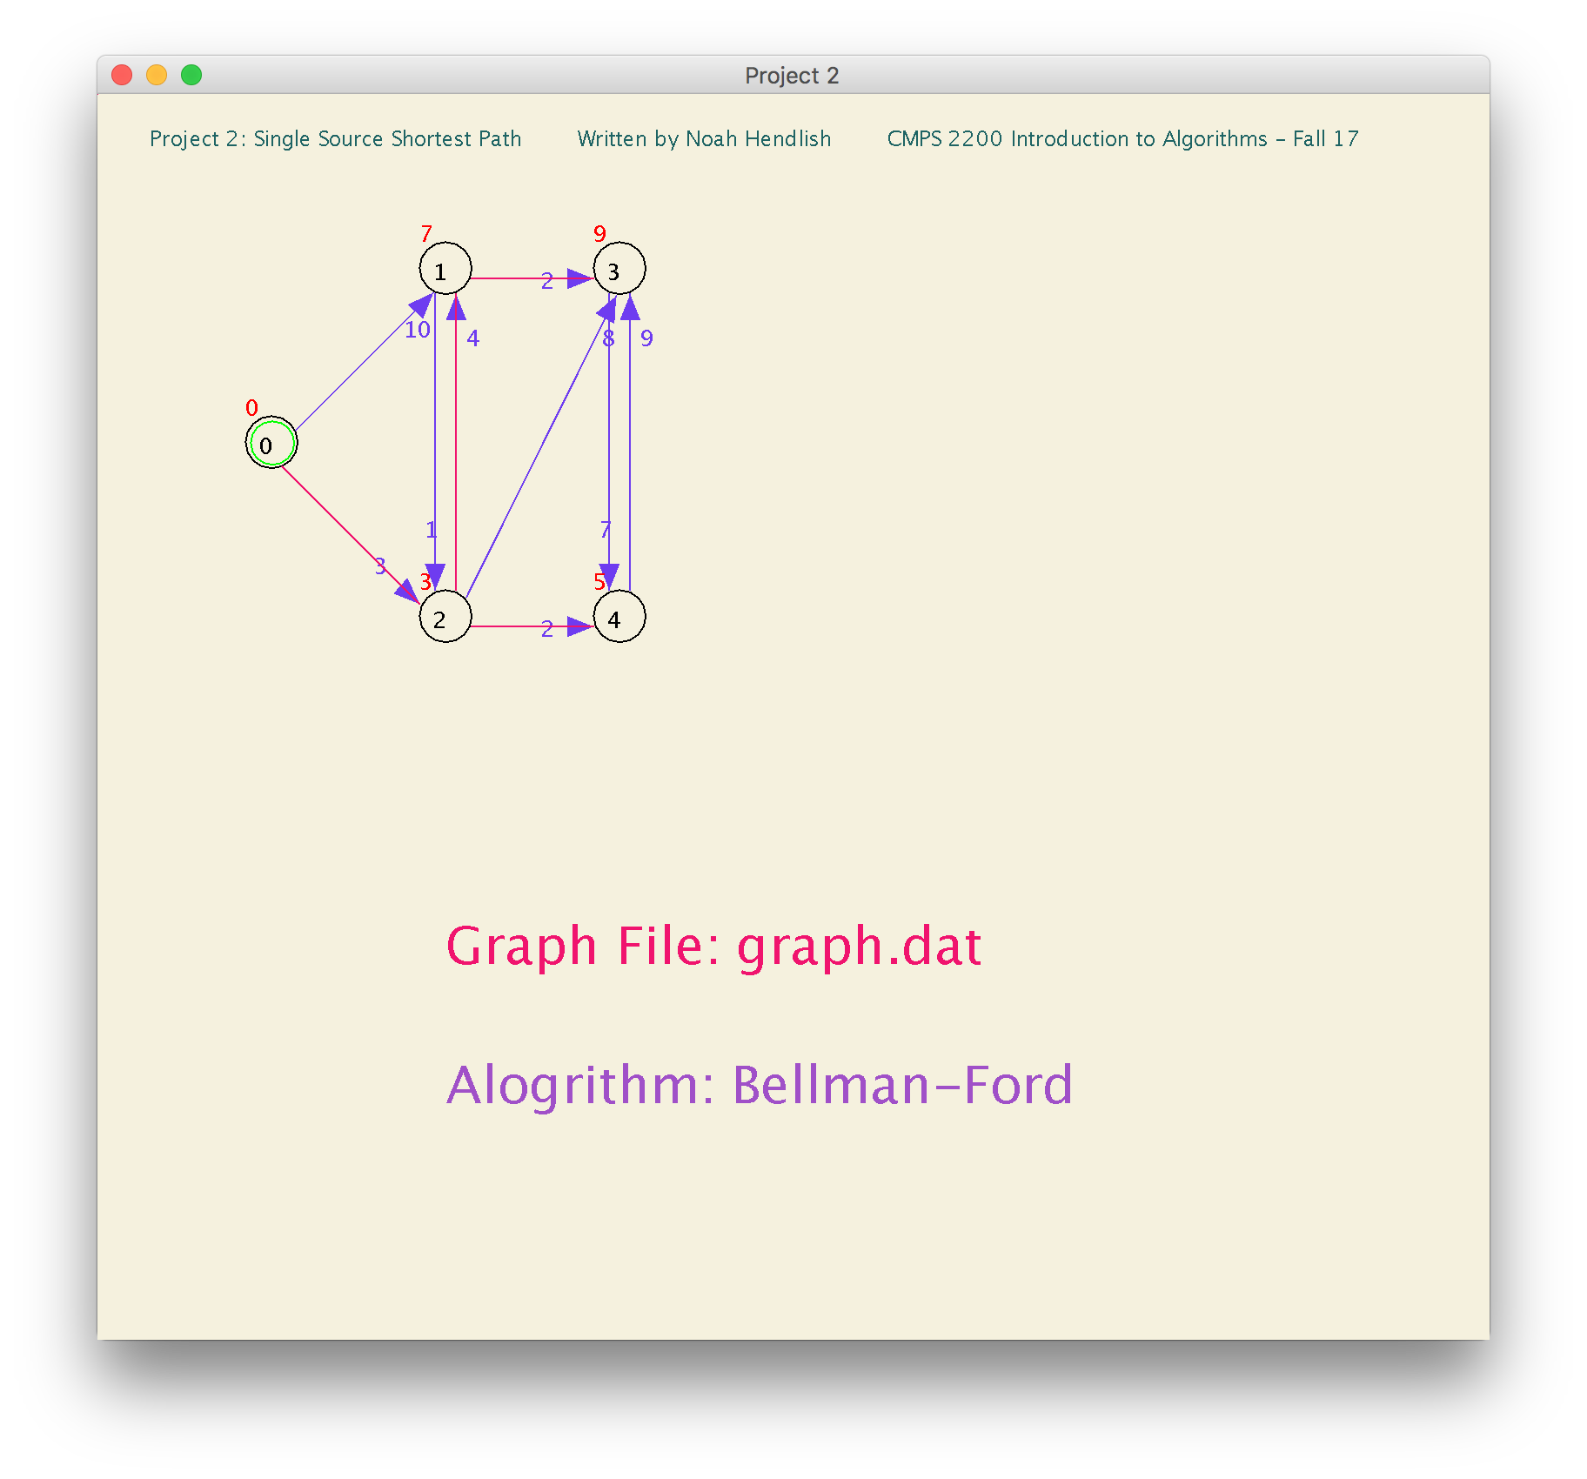

Graph does not contain any negative weight cycles, so Bellman-Ford can find shortest path.

**d-Values for Bellman-Ford on graph.dat**

*(d-Value of 0 means vertex is source, d-value of null means vertex has infinity/max d-value. If Vertex's d-value is null (e.g. it has infinity/max-d-value), it was not traversed since it is inaccessible from source)

**Vertex: 0 1 2 3 4**

**d-Value: 0 7 3 9 5**

**Predecessor Array for Bellman-Ford on graph.dat**

*(Predecessor ID / Value of -1 means vertex has no predecessor, e.g., the source vertex has predecessor of -1. Non-source vertex with -1 predecessor ID was not traversed since it is inaccessible from source)

**Vertex: 0 1 2 3 4**

**Predecessor: -1 2 0 1 2**

*Note: SINCE THIS GRAPH CONTAINS NO EDGES WITH NEGATIVE WEIGHTS, BELLMAN FORD AND DJIKSTRA FIND THE EXACT SAME SHORTEST PATH/OUTPUT (same predecessor array, same d-values for all vertices).

**Dijkstra on graphNeg.dat (Negative Weight Directed Graph)**

**Source Vertex ID: 0**

*When running Dijkstra on Graph with negative edge weights, reports in GUI and console.

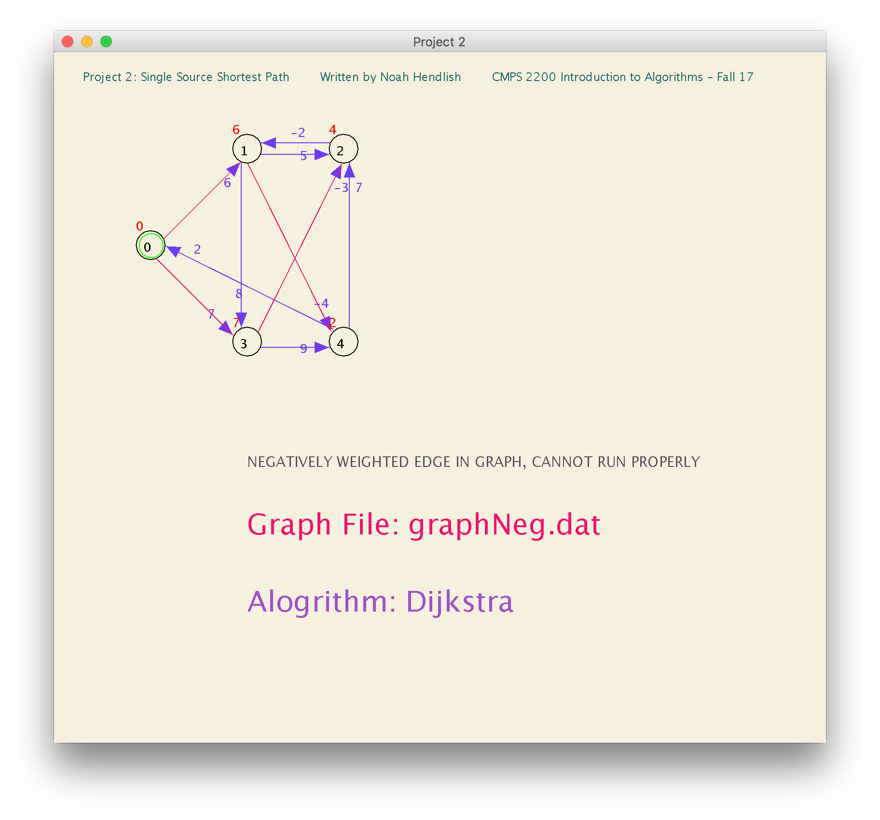

*Dijkstra’s single source shortest path algorithm can only find the optimal shortest path on graphs with non-negative weighed edges. Since this edge has a negative weight.

**d-Values for Dijkstra on graphNeg.dat**

*(d-Value of 0 means vertex is source, d-value of null means vertex has infinity/max d-value. If Vertex's d-value is null (e.g. it has infinity/max-d-value), it was not traversed since it is inaccessible from source)

**Vertex: 0 1 2 3 4**

**d-Value: 0 6 4 7 2**

**Predecessor Array for Dijkstra on graphNeg.dat**

*(Predecessor ID / Value of -1 means vertex has no predecessor, e.g., the source vertex has predecessor of -1. Non-source vertex with -1 predecessor ID was not traversed since it is inaccessible from source)

**Vertex: 0 1 2 3 4**

**Predecessor: -1 0 3 0 1**

**Console reports:**

graphNeg.dat contains edges with Negative weights, Dijkstra cannot handle negatively weighted graphs.

Try using Bellman Ford on graphNeg.dat

As stated above, Dijkstra cannot handle negatively weighted edges in graphs. Since Dijkstra uses a queue that is constantly updated, iterating through vertices based on the minimum d-values.

(relaxing edges once checked) … further explanation on page 5.

**Explanation Negatively Weighted Edges in Graph (on Djikstra and comparison to Bellman-Ford)**

*Refer to queue diagram below and Graphs on Page 4 (for Dijkstra on Negatively weighted graph) and on Page 6 (for Bellman-Ford on a Negatively weighted graph)

In the graph above, Dijkstra starts at vertex 0 (the source) and checks vertices 1 and 2, since they’re d-values are initially infinity it updates them to 0 + weight. Thus V1 has d-value of 6 and V3- has d-Value of 7. V1 and V3 are added to the queue. And the source vertex is removed from the queue. V1 is next in the queue. Dijkstra checks if any of V1’s adjacent vertices can be updated (i.e are smaller than V1 + weight of edge), the edge from V1 to V3 has weight 8 and V1 has a d-value of 2, and V3 has a d-value of 7 so 3 is not update. V4 and V2 have not been considered yet (have d-values of infinity), thus their d-values are updated to (d-value.V1+ w(V1,V4) = 6 + (-4) = 2), so V4 has d-value of 2 and it does the same for V2 (6+5 = 11), so V2 has a d-value of 11 now. Next in the queue is V4 (has min d-value (=2) of vertices in queue), it goes through all of V4’s edges, updating them if necessary and relaxing them. The only update is V2’s d-value to 9. V3 has d-value of 7 (which is min-value of vertices in queue since its just V3 and V2 in queue) so the algorithm checks all of V3’s adjacent vertices, it updates V2’s d-value to 4 (previously 9 > 7 (d-value of V3) + (-3) (weight of edge)). V4 is the last vertex in the queue, it checks its adjacent vertices but the vertices are no longer in the queue and relaxed, so V4 doesn’t update anything and relaxes its edges.

**The queue (with d-values):**

**\*QUEUE IS CONSTANTLY UPDATED, NEXT VALUE IS VALUE WITH MINIMUM D-VALUE.**

Q: 0 1 2 3 4  **\*min d-values in queue are bolded**

d-values:

**0** ∞ ∞ ∞ ∞ * “-”means vertex de-queued

- **6** ∞ 7 ∞

- 11 7 **2**

9 **7 -**

**4** -

-

At this point Dijkstra has completed running but has not found the shortest path as V2 should have a d-value of 2 and V4 should have a d-value of -2…

While Dijkstra cannot handle negative weights, Bellman-Ford can.

Since this graph does not have any negative weight CYCLES, Bellman-Ford can find the shortest path…

Bellman ford can find the shortest-path from a source to all vertices in graph as long as there is not a negative weight cycle, thus Bellman-Ford also checks whether or not a negative-weight cycle exists.

This graph does not contain any negative weight cycle, so Bellman Ford can find shortest path in graphNeg.dat. Unlike Dijkstra, that uses a queue, Bellman Ford, goes through every edge n (# of vertices in graph) times, which is much costlier and less time efficient than Dijkstra but is accurate (at finding the shortest path) when handling graphs that contain negatively weighted edge.

**Bellman-Ford on graphNeg.dat (Negative Weight Directed Graph)**

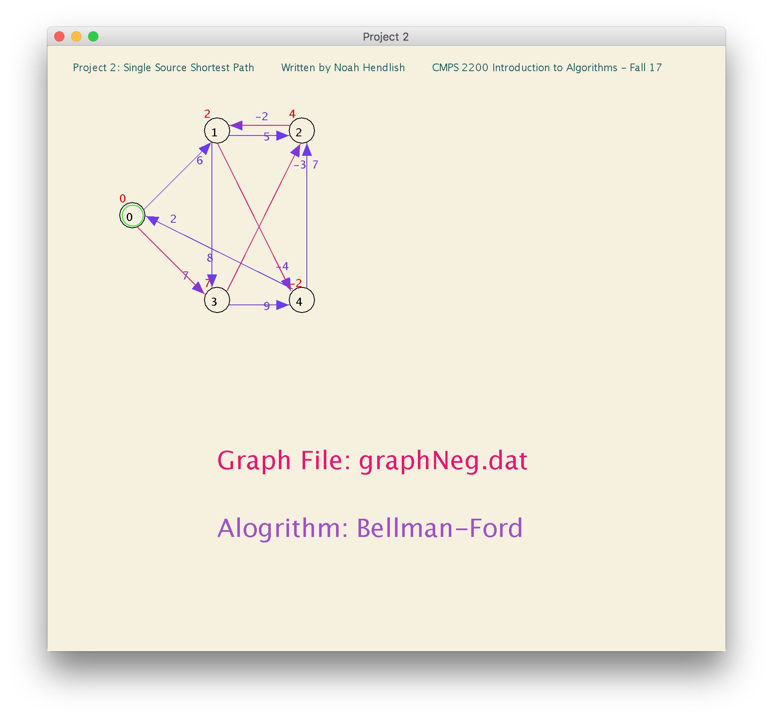**Source Vertex ID: 0**

**d-Values for Bellman-Ford on graphNeg.dat**

*(d-Value of 0 means vertex is source, d-value of null means vertex has infinity/max d-value. If Vertex's d-value is null (e.g. it has infinity/max-d-value), it was not traversed since it is inaccessible from source)

Vertex: 0 1 2 3 4

d-Value: 0 2 4 7 -2

Predecessor Array for Bellman-Ford on graphNeg.dat

*(Predecessor ID / Value of -1 means vertex has no predecessor, e.g., the source vertex has predecessor of -1. Non-source vertex with -1 predecessor ID was not traversed since it is inaccessible from source)

Vertex: 0 1 2 3 4

Predecessor: -1 2 3 0 1

*As explained on page 5, Bellman-Ford finds the shortest path on any graph without a negative cycle

**Dijkstra on graphNegCycle.dat (Negative Cycle Directed Graph)**

**Source Vertex ID: 0**

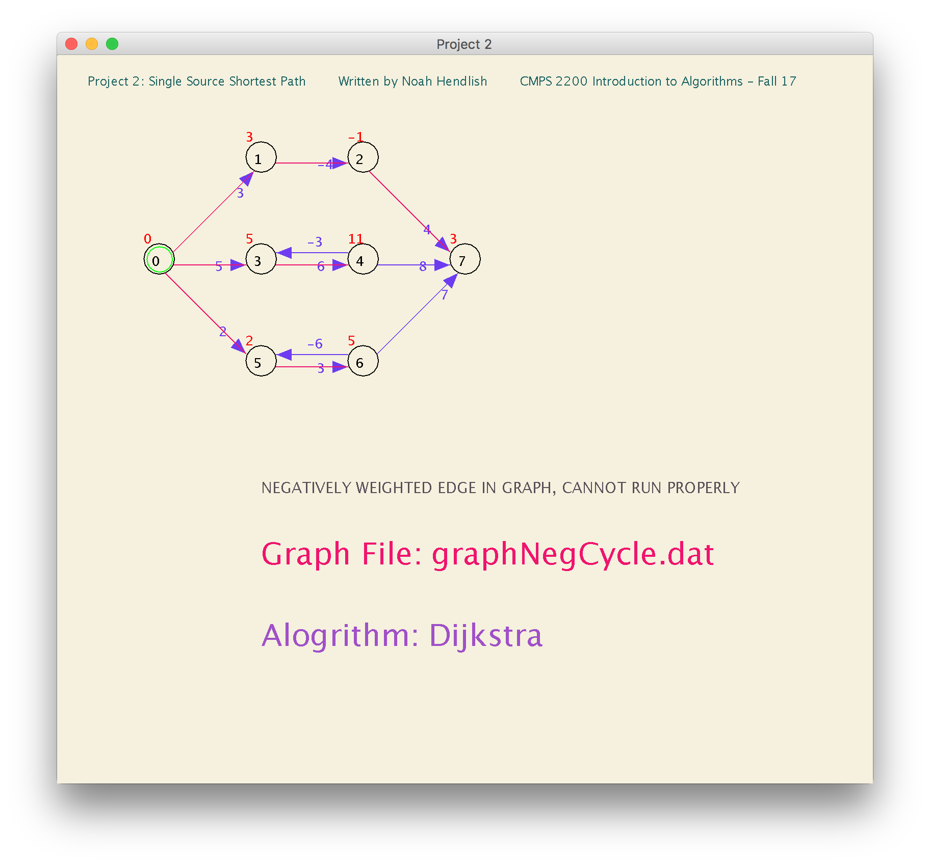

**d-Values for Dijkstra on graphNegCycle.dat**

*(d-Value of 0 means vertex is source, d-value of null means vertex has infinity/max d-value. If Vertex's d-value is null (e.g. it has infinity/max-d-value), it was not traversed since it is inaccessible from source)

**Vertex: 0 1 2 3 4 5 6 7**

**d-Value: 0 3 -1 5 11 2 5 3**

**Predecessor Array for Dijkstra on graphNegCycle.dat**

*(Predecessor ID / Value of -1 means vertex has no predecessor, e.g., the source vertex has predecessor of -1. Non-source vertex with -1 predecessor ID was not traversed since it is inaccessible from source)

**Vertex: 0 1 2 3 4 5 6 7**

**Predecessor: -1 0 1 0 3 0 5 2**

**Console Reports:**

graphNegCycle.dat contains edges with Negative weights, Dijkstra cannot handle negatively weighted graphs.

Try using Bellman Ford on graphNegCycle.dat

As explained on page 5, Dijkstra cannot run properly on graphs with negative weights, especially not graphs with negative weight cycles. Even Bellman Ford cannot find the shortest path on graphs with negative weight cycles.

**Bellman-Ford on graphNegCycle.dat (Negative Cycle Directed Graph)**

**Source Vertex ID: 0**

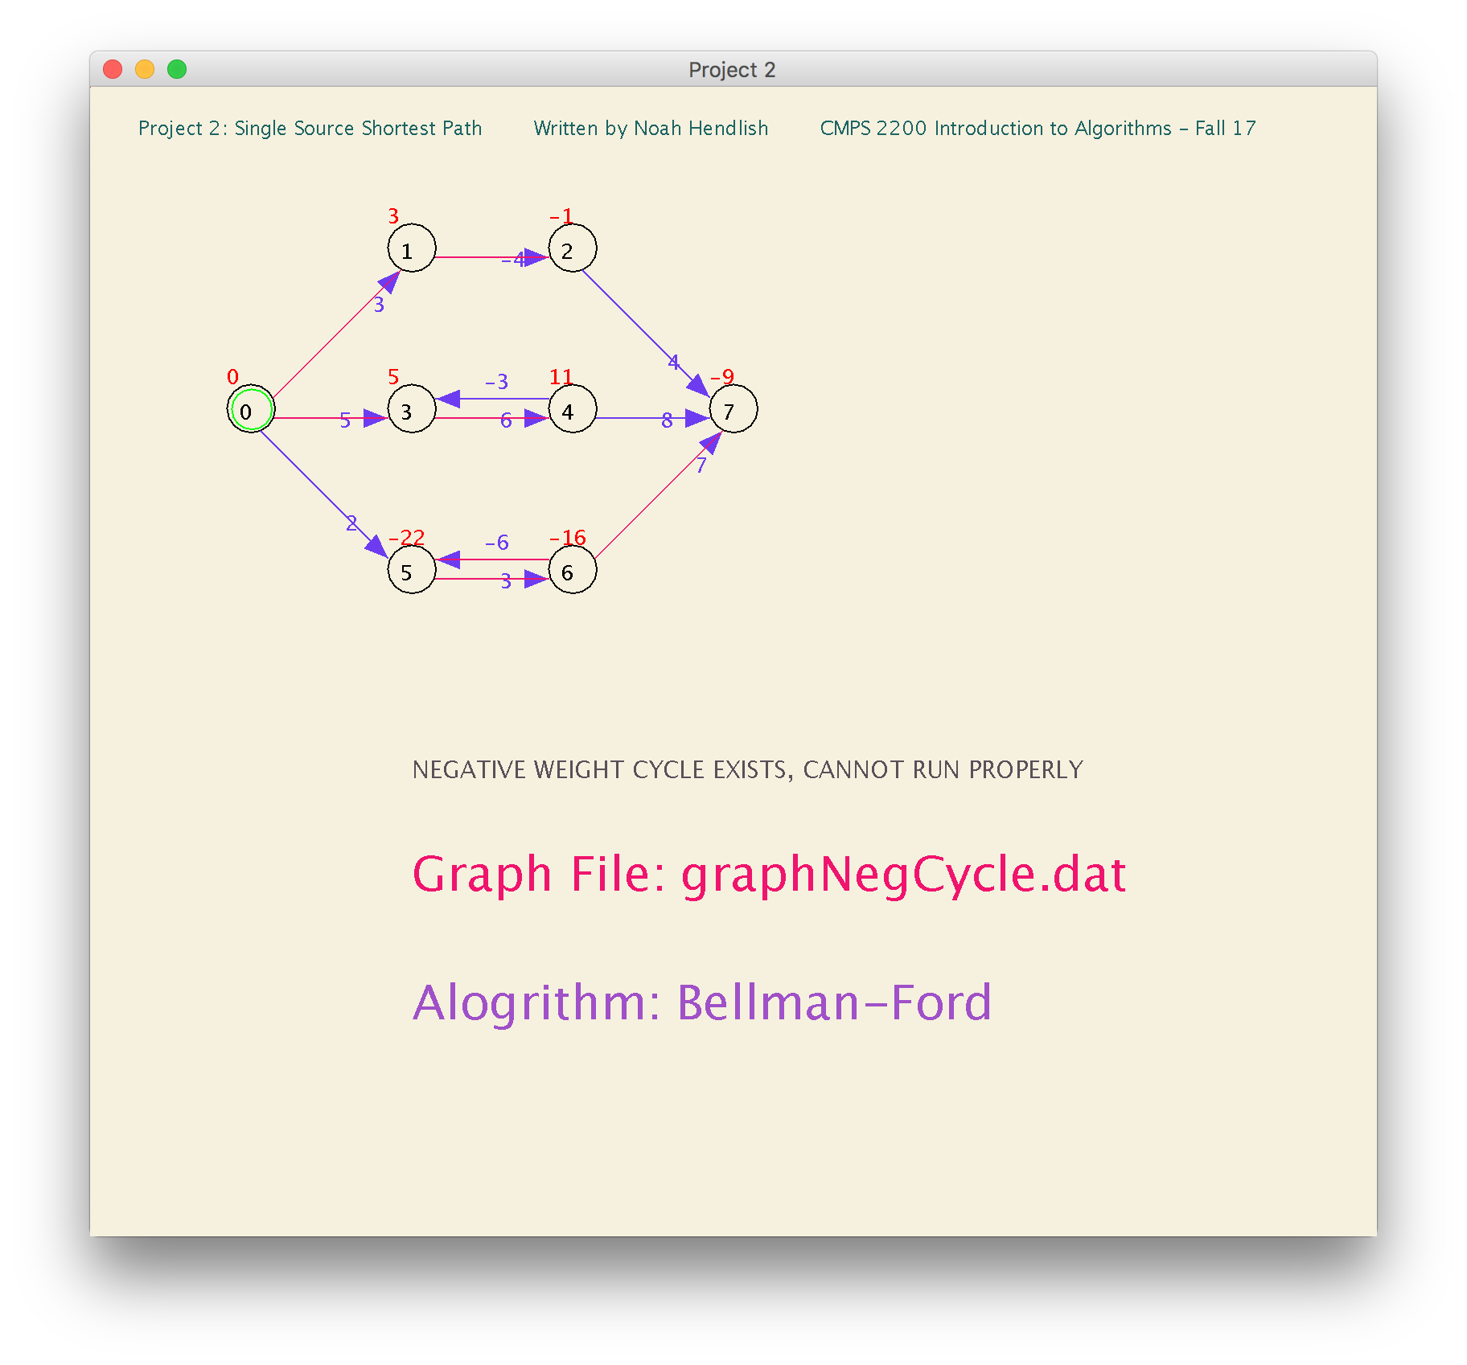

Bellman-Ford Algorithm Detects that Graph contains negative weight cycle.

It finds a negative weight cycle caused by edge between vertex 5 to vertex 6.

**d-Values for Bellman-Ford on graphNegCycle.dat**

*(d-Value of 0 means vertex is source, d-value of null means vertex has infinity/max d-value. If Vertex's d-value is null (e.g. it has infinity/max-d-value), it was not traversed since it is inaccessible from source)

**Vertex: 0 1 2 3 4 5 6 7**

**d-Value: 0 3 -1 5 11 -22 -16 -9**

**Predecessor Array for Bellman-Ford on graphNegCycle.dat**

*(Predecessor ID / Value of -1 means vertex has no predecessor, e.g., the source vertex has predecessor of -1. Non-source vertex with -1 predecessor ID was not traversed since it is inaccessible from source)

**Vertex: 0 1 2 3 4 5 6 7**

**Predecessor: -1 0 1 0 3 6 5 6**

**Explanation for Negative Weight Cycles**

Obviously Dijkstra cannot handle a graph with a negative weight cycle since it can’t handle graphs with any negatively weighted edges (see page 5). Bellman-Ford can find the shortest path on graphs that contain edges with negative weights, as long as a negative weight cycle does not exist.

In the example graph (*graphNegCycle*.*dat*), there is a negative weight cycle between vertex 5 and vertex 6 (as Bellman-Ford reported in the console). This negative weight cycle causes a problem for bellman ford.

For the 1st iteration of the outer for-loop, initially vertex 5 gets a d-value of 2 (V0.dvalue + w(V0,V5) = 2) then vertex 6 gets a d-value of 5 (V5.dvalue + w(V5,V6) = 5). But, Since there is an edge from vertex 6 to vertex 5 (with weight -6), when that edge is iterated, vertex 5’s d-value is updated to -1.

Then in the 2nd iteration of the outer for-loop, initially, vertex 5’s d-value is not updated, as -1 < 5, and vertex 6’s d-value is updated to 2 (-1+3 = 2). THEN when the edge from vertex 6 to vertex 5, with weight - 6 = w(V6, V5) is traversed, V5’s d-value is update from -1 to -4 (V6.dvalue + w(V6, V5) = 2 – 6 = -4).

In the 3rd iteration of the outer for-loop, Vertex 5’s d-value is not updated, as (V(0).dvalue + w(V0,V5) = 0+2 > -4). Vertex 6’s d-value is then updated to -1 (-4+3), THEN vertex 5’s d-value is update to -7.

And for the rest of the iterations of the outer for-loop, the same pattern continues…

In such a way:

****At end of ith Iteration the following updates are made…

i= 1 2 3 4 5 6 7 8

Vertex 5 d-Value: -1 -4 -7 -10 -13 -16 -19 -22

Vertex 6 d-Value: 5 2 -1 -4 -7 -10 -13 -16

(* 8 iterations that go through every single edge since there are 8 vertices)

Now there are a few problems with this, the cause of it is simply the negative weight cycle between vertex 6 and vertex 5. V5 is only accessible from V0 and V6, AND V6 is only accessible from V5. After the first iteration, vertex 0 will never update vertex 5, thus there will never be an edge from V0 to V5, which makes it such that V5 and V6 are isolated, thus there is no shortest path from the source (V0) to V5 or V6. Additionally, since there is a negative weight cycle, in theory the d-values of vertex 5 and 6 could updated infinitely (but realistically n many times) by -3. This explains why V5’s d-value is currently -22 and V6’s d-value is -16. The number of vertices, n = 8, is 8. Thus, V5’s d-value is (1*-1 + -3*7 = -22). In the first iteration V5’s d-value is -1 but, every other iteration after that, it decreases by -3… Similarly, V6’s d-value is (1*5+ -3*7), as in the first iteration V6’s d-value is 5, and every iteration after it decreases by -3.

**Dijkstra on graphUndirected.dat (Undirected Graph)**

**Source Vertex ID: 0**

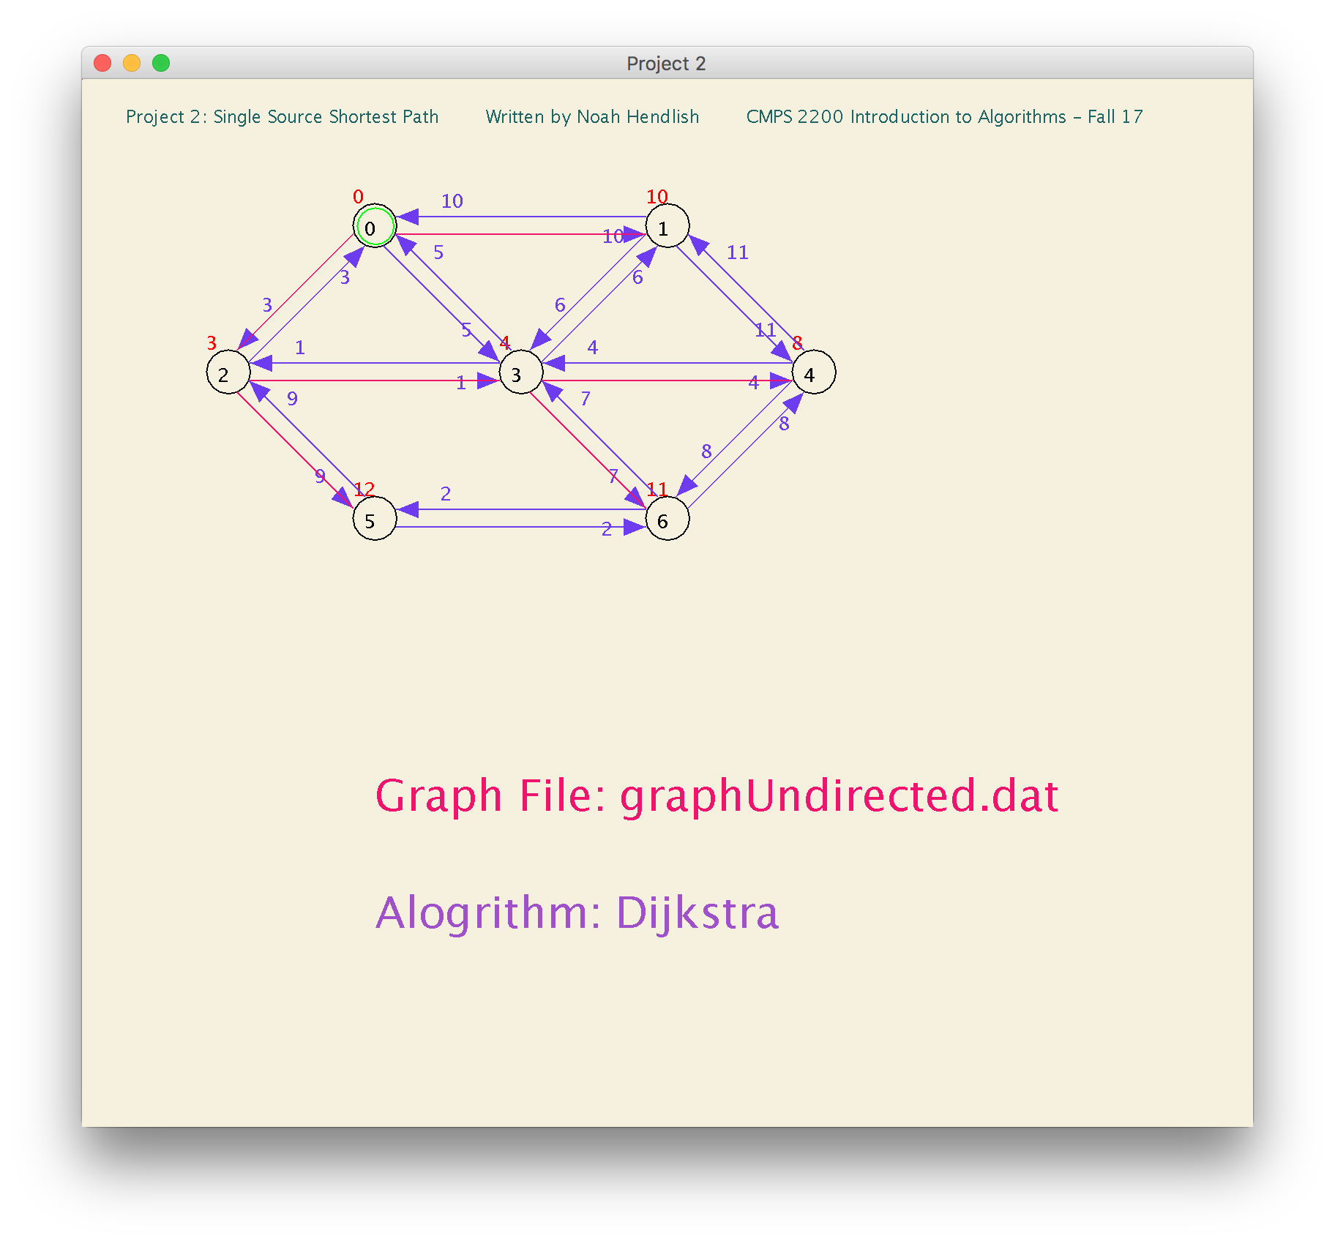

Graph does not contain any negatively weighted edges. All Edge weights positive. Dijkstra can find the shortest path.

**d-Values for Dijkstra on graphUndirected.dat**

*(d-Value of 0 means vertex is source, d-value of null means vertex has infinity/max d-value. If Vertex's d-value is null (e.g. it has infinity/max-d-value), it was not traversed since it is inaccessible from source)

**Vertex: 0 1 2 3 4 5 6**

**d-Value: 0 10 3 4 8 12 11**

**Predecessor Array for Dijkstra on graphUndirected.dat**

*(Predecessor ID / Value of -1 means vertex has no predecessor, e.g., the source vertex has predecessor of -1. Non-source vertex with -1 predecessor ID was not traversed since it is inaccessible from source)

**Vertex: 0 1 2 3 4 5 6**

**Predecessor: -1 0 0 2 3 2 3**

**Bellman-Ford on graphUndirected.dat (Undirected Graph)**

**Source Vertex ID: 0**

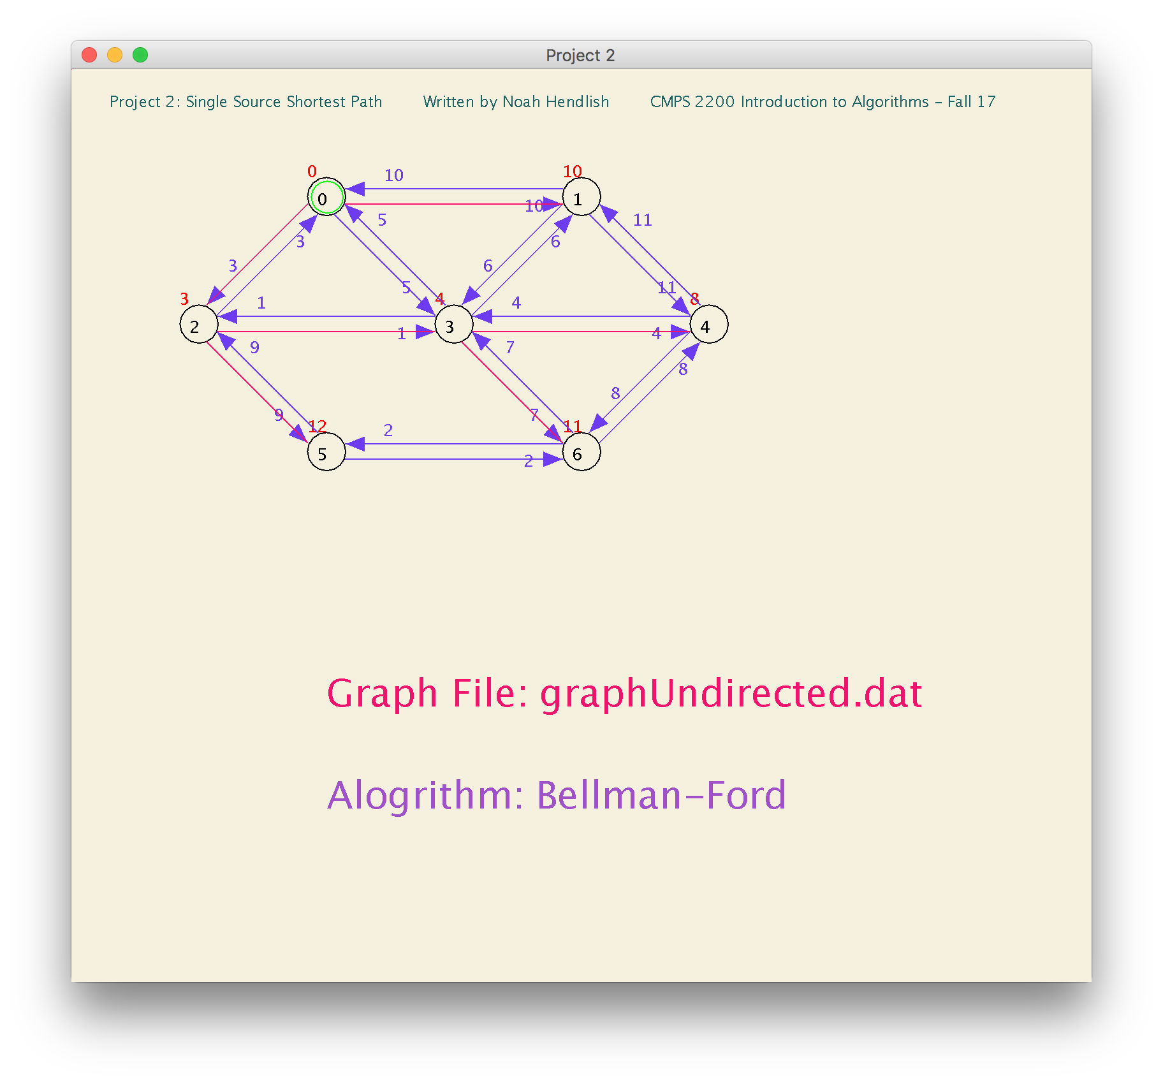

Graph does not contain any negative weight cycles.

**d-Values for Bellman-Ford on graphUndirected.dat**

*(d-Value of 0 means vertex is source, d-value of null means vertex has infinity/max d-value. If Vertex's d-value is null (e.g. it has infinity/max-d-value), it was not traversed since it is inaccessible from source)

**Vertex: 0 1 2 3 4 5 6**

**d-Value: 0 10 3 4 8 12 11**

**Predecessor Array for Bellman-Ford on graphUndirected.dat**

*(Predecessor ID / Value of -1 means vertex has no predecessor, e.g., the source vertex has predecessor of -1. Non-source vertex with -1 predecessor ID was not traversed since it is inaccessible from source)

**Vertex: 0 1 2 3 4 5 6**

**Predecessor: -1 0 0 2 3 2 3**

**Positively Weighted Graphs**

Like the Non-negative weight directed graph, Dijkstra and Bellman-Ford can both find the shortest path for an Undirected graph (so long as it has positive edge weights), thus they have the same outcome (same d-values, predecessor array, and path), however Dijkstra is faster, so if you’re sure a graph will not contain a negative weighted edge, Dijkstra is ideal algorithm for finding shortest paths.





**Shortest Path from Any Source on Undirected/Strongly Connected Graphs**

The previous graphs (all graphs before the undirected graph), contained vertices that were inaccessible from any given source, but all vertices were reachable if the source was zero, thus for the first three graphs I only tested using the source that could find a shortest path to all vertices in the graph (Vertex 0).

***For example:***

**Choosing Vertex 2 as the source on graph.dat and running Bellman-Ford or Dijkstra:**

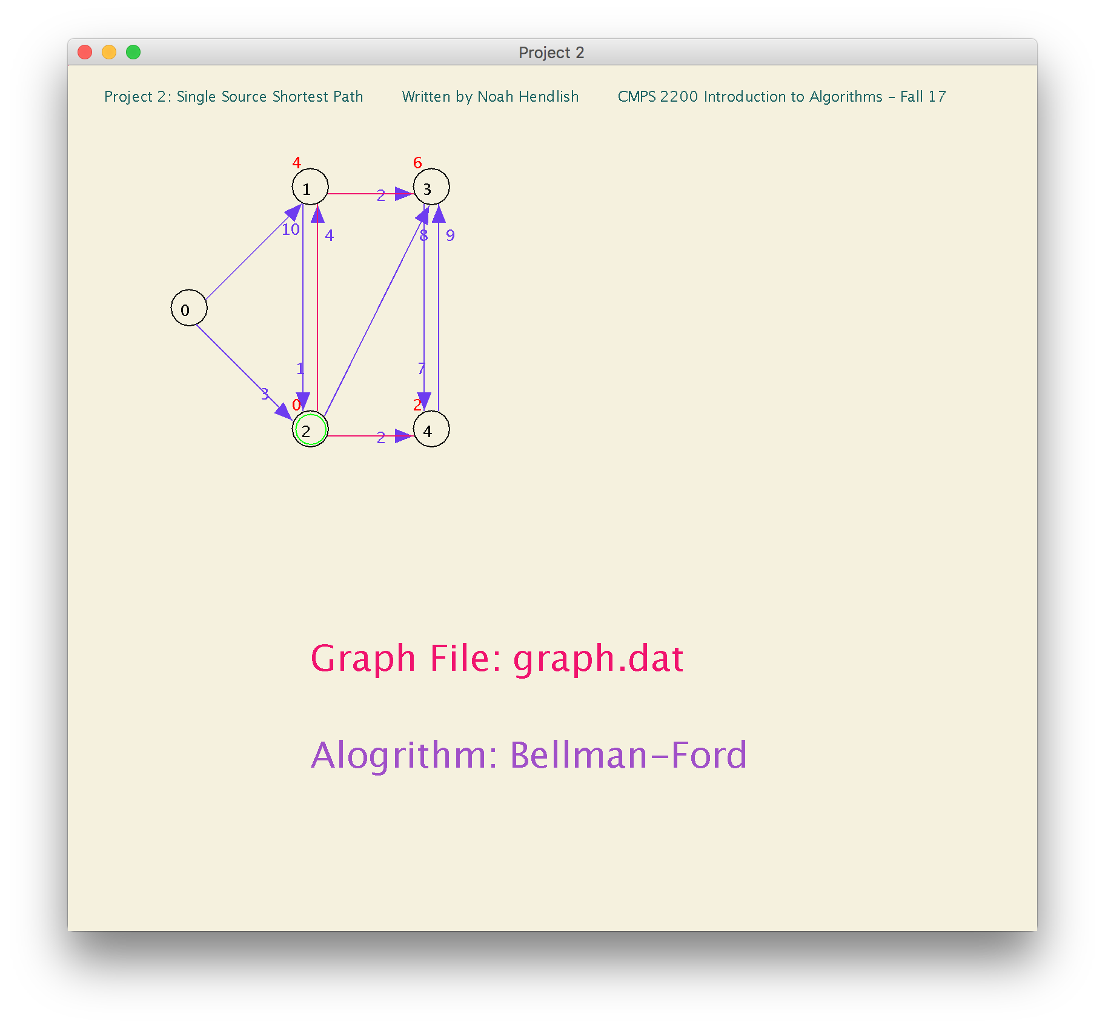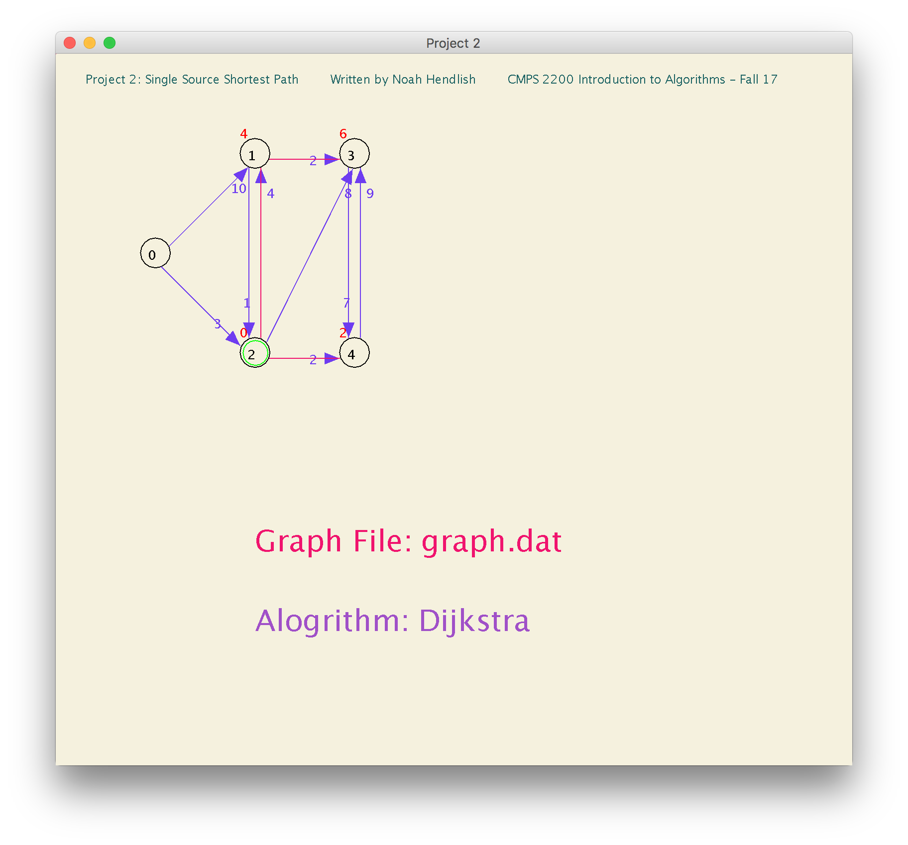

***It runs, but cannot find the shortest path to vertex zero.***

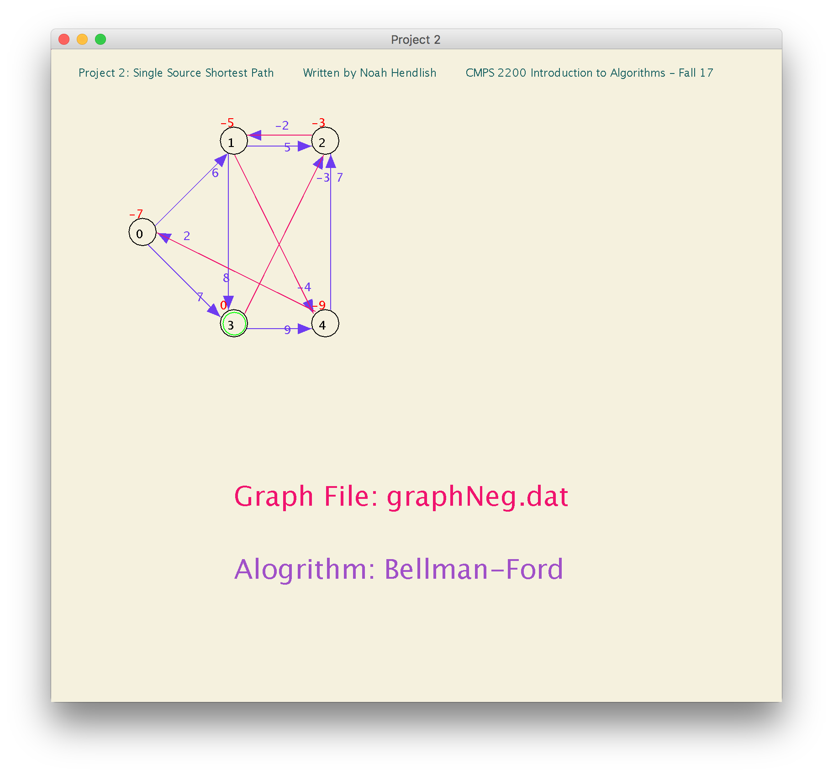

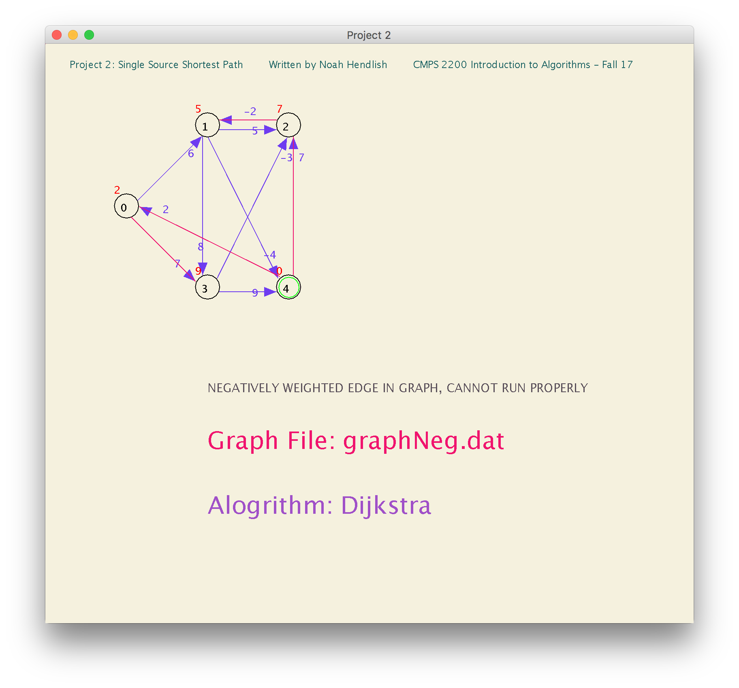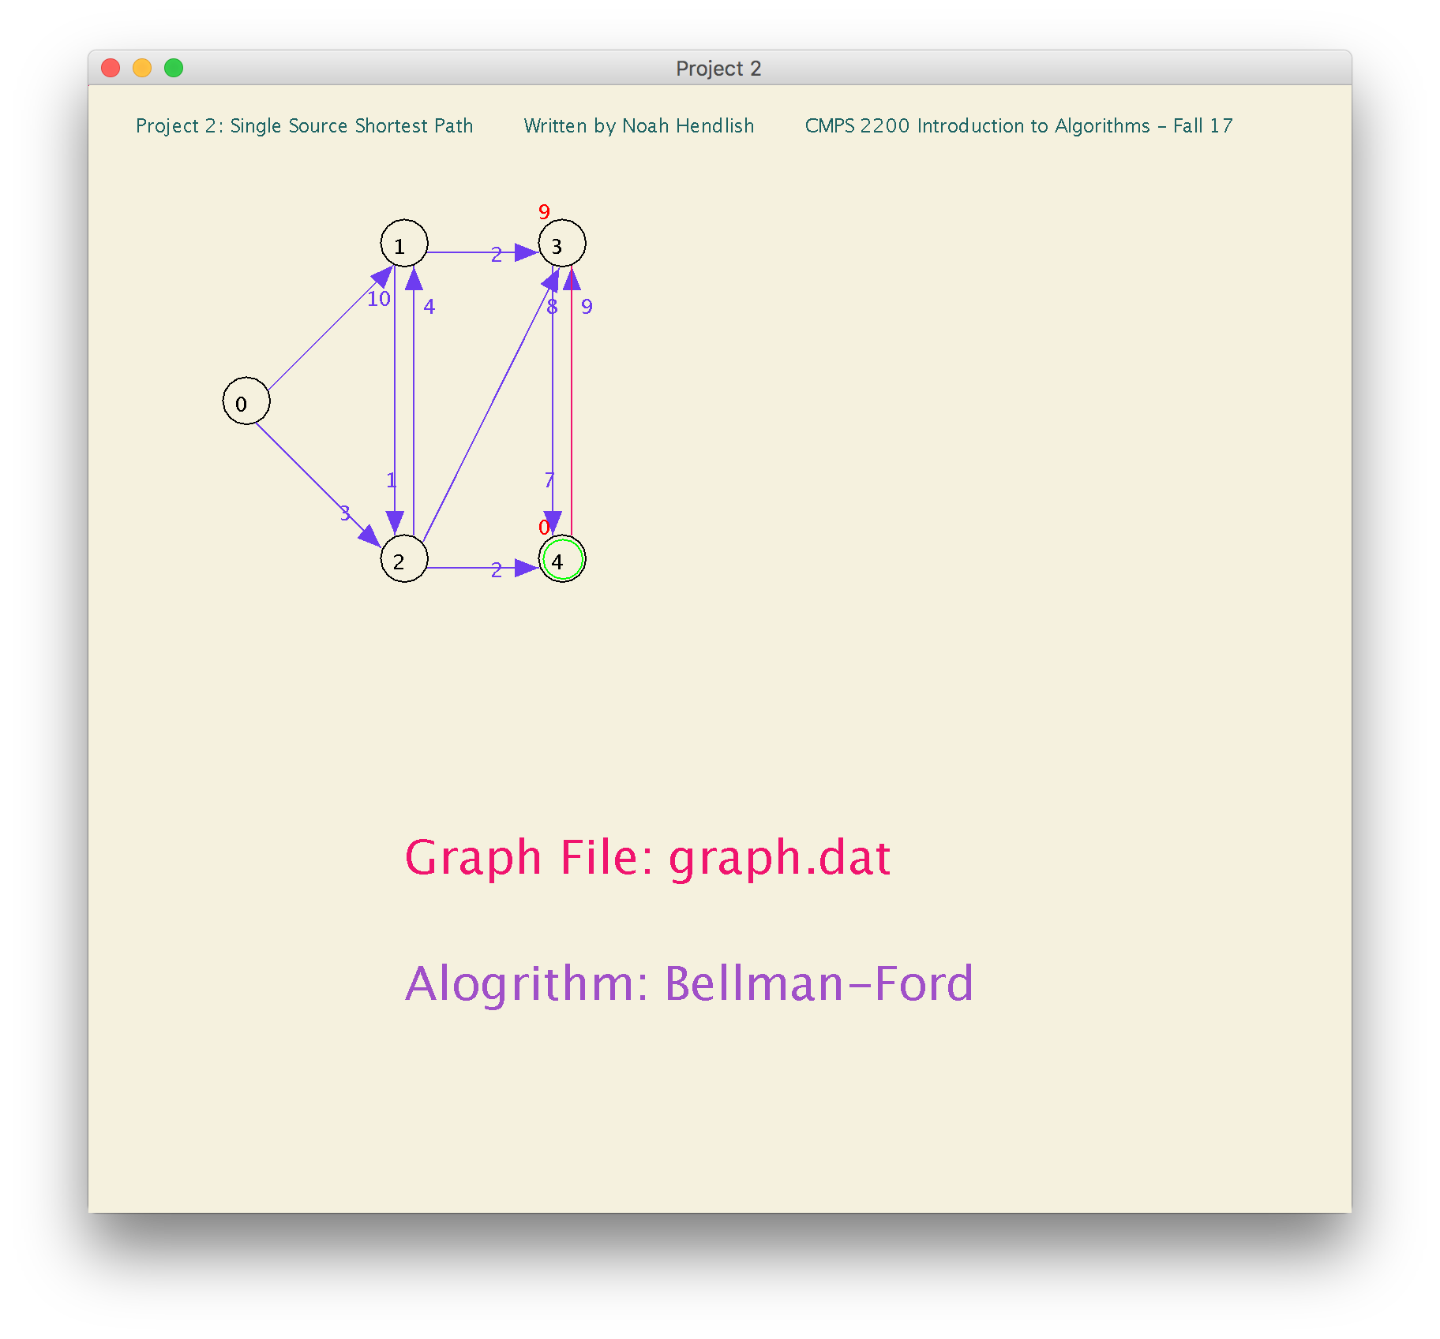**OR any of the following:**

*Did not add screenshots of alternative sources for the algorithms running on the Negative weight graph, because we’ve established that neither algorithm can find a shortest path.

I tested the program using Djikstra and Bellman-Ford on different source vertices on the graphUndirected.dat graph and other strongly connected graph’s (without negative edge weights) that I made so that you can find the shortest path from any given vertex to every vertex in the graph.

(next page)

***ADDITIONAL TESTING:***

*Since graphUndirected.dat is undirected and connected, we can set the source to any vertex.

**Dijkstra on graphUndirected.dat (Undirected Graph)**

**Source Vertex ID: 1**

Running Djikstra on graphUndirected.dat

Graph does not contain any negatively weighted edges. All Edge weights positive. Dijkstra can find the shortest path.

**d-Values for Dijkstra on graphUndirected.dat**

Vertex: 0 1 2 3 4 5 6

d-Value: 10 0 7 6 10 15 13

**Predecessor Array for Dijkstra on graphUndirected.dat**

Vertex: 0 1 2 3 4 5 6

Predecessor: 1 -1 3 1 3 6 3

**Bellman-Ford on graphUndirected.dat (Undirected Graph)**

**Source Vertex ID: 1**

Running Bellman Ford on graphUndirected.dat

Graph does not contain any negative weight cycles.

**d-Values for Bellman-Ford on graphUndirected.dat**

Vertex: 0 1 2 3 4 5 6

d-Value: 10 0 7 6 10 15 13

**Predecessor Array for Bellman-Ford on graphUndirected.dat**

Vertex: 0 1 2 3 4 5 6

Predecessor: 1 -1 3 1 3 6 3

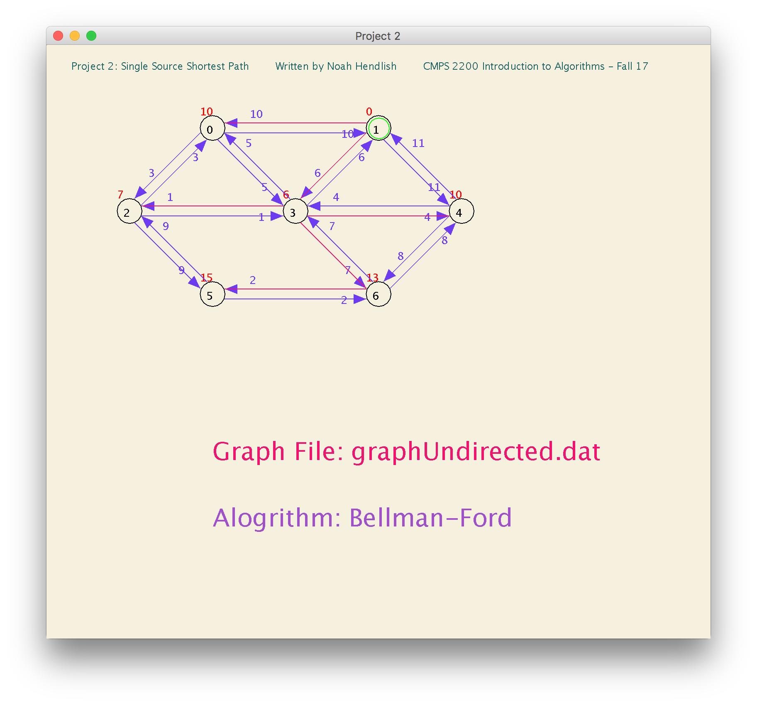

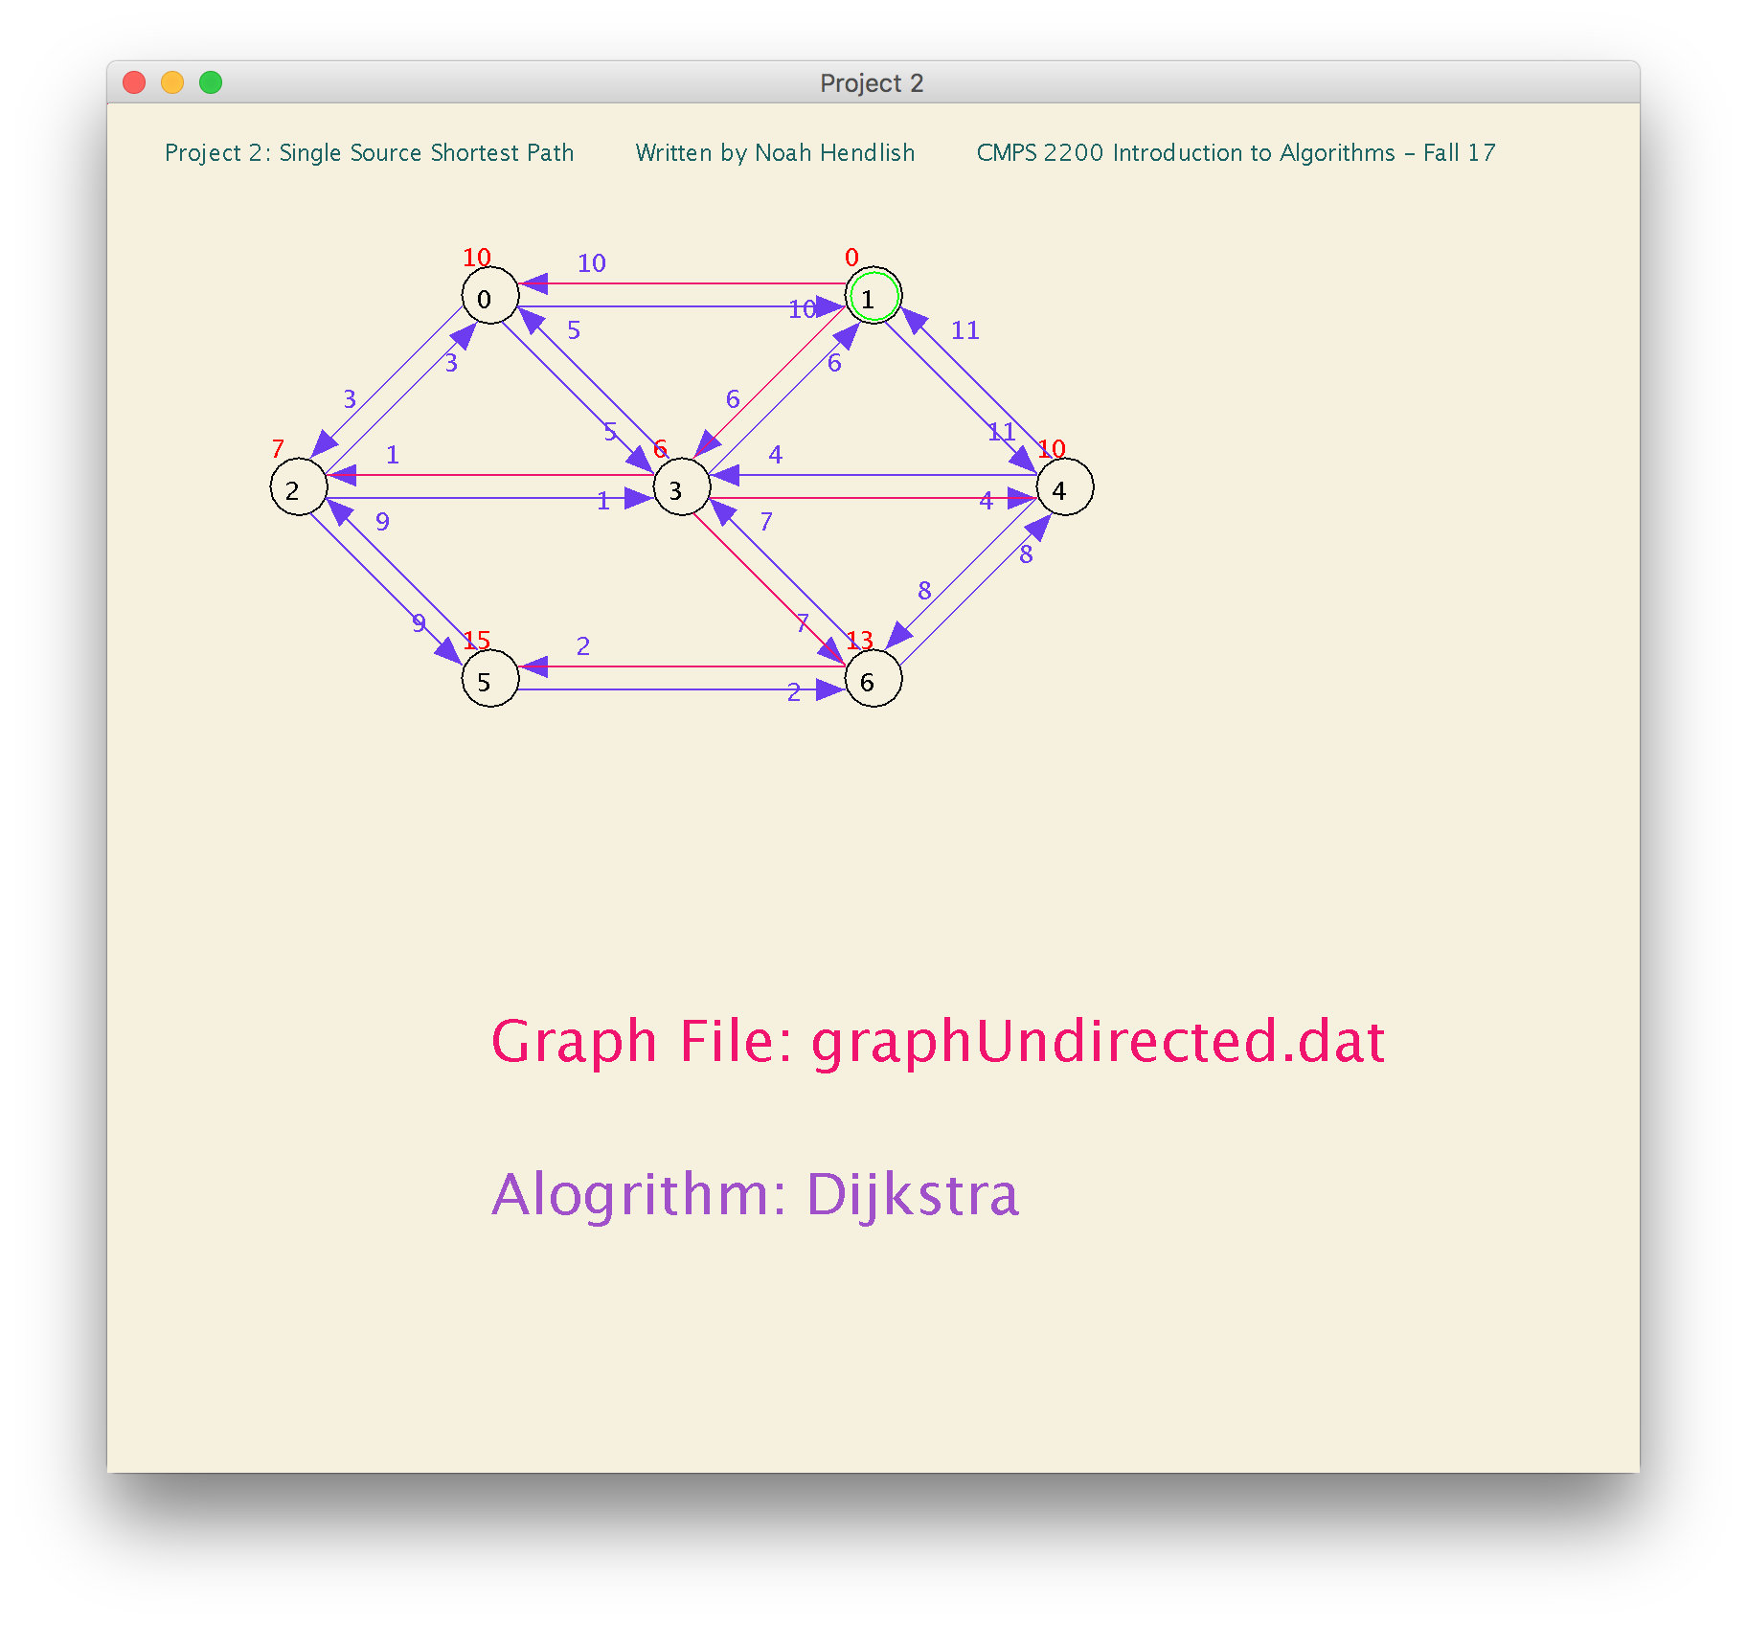

*both algorithms have same outcomes.

**Bellman-Ford on graphUndirected.dat (Undirected Graph)**

**Source Vertex ID: 3**

Running Bellman Ford on graphUndirected.dat

Graph does not contain any negative weight cycles.

**d-Values for Bellman-Ford on graphUndirected.dat**

Vertex: 0 1 2 3 4 5 6

d-Value: 4 6 1 0 4 9 7

**Predecessor Array for Bellman-Ford on graphUndirected.dat**

Vertex: 0 1 2 3 4 5 6

Predecessor: 2 3 3 -1 3 6 3

**Dijkstra on graphUndirected.dat (Undirected Graph)**

**Source Vertex ID: 3**

Running Djikstra on graphUndirected.dat

Graph does not contain any negatively weighted edges. All Edge weights positive. Dijkstra can find the shortest path.

**d-Values for Dijkstra on graphUndirected.dat**

Vertex: 0 1 2 3 4 5 6

d-Value: 4 6 1 0 4 9 7

**Predecessor Array for Dijkstra on graphUndirected.dat**

Vertex: 0 1 2 3 4 5 6

Predecessor: 2 3 3 -1 3 6 3

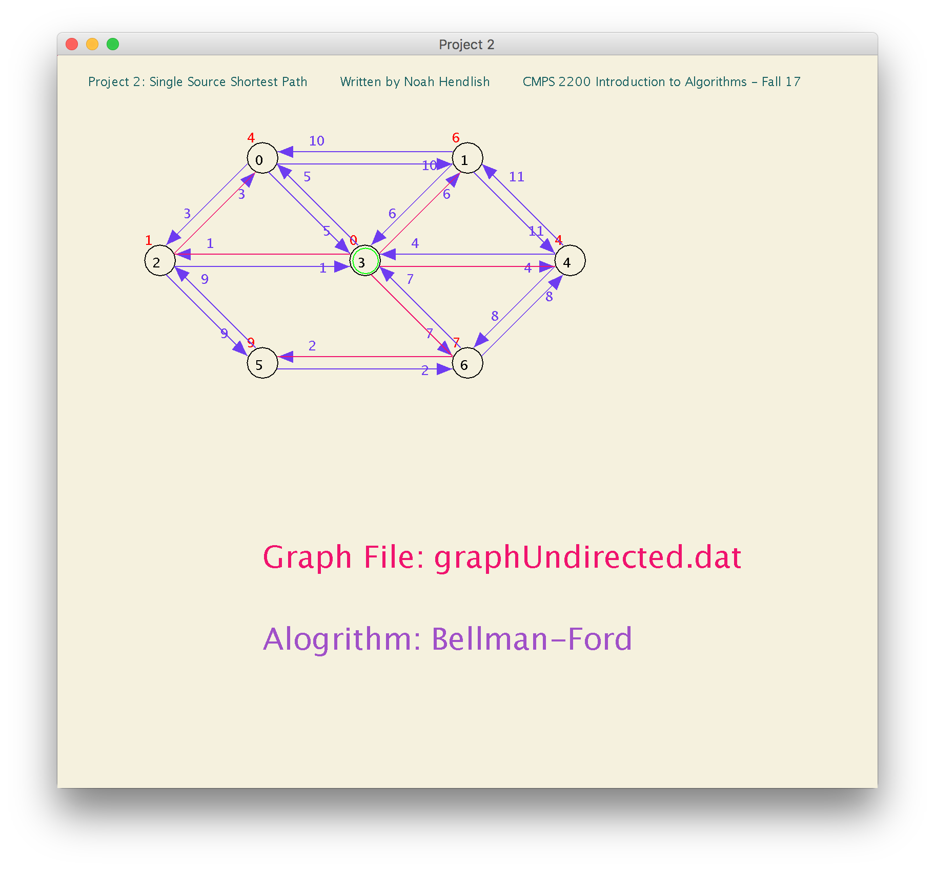

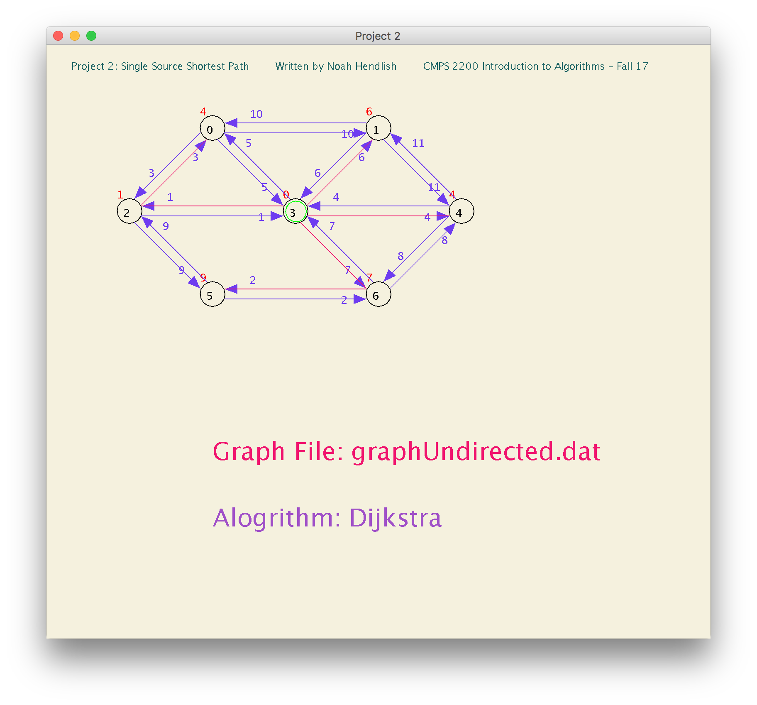

**Additional Graphs I made**

**Dijkstra on test1.dat (First Test Graph that I Created: Strongly Connected Graph)**

**Source Vertex ID: 5**

Graph does not contain any negatively weighted edges. All Edge weights positive. Dijkstra can find the shortest path.

**d-Values for Dijkstra on test1.dat**

Vertex: 0 1 2 3 4 5 6 7

d-Value: 6 5 1 4 17 0 13 11

**Predecessor Array for Dijkstra on test1.dat**

Vertex: 0 1 2 3 4 5 6 7

Predecessor: 5 2 5 5 6 -1 3 2

**Bellman-Ford on test1.dat (First Test Graph that I Created: Strongly Connected Graph)**

**Source Vertex ID: 5**

Graph does not contain any negative weight cycles.

**d-Values for Bellman-Ford on test1.dat**

Vertex: 0 1 2 3 4 5 6 7

d-Value: 6 5 1 4 17 0 13 11

**Predecessor Array for Bellman-Ford on test1.dat**

Vertex: 0 1 2 3 4 5 6 7

Predecessor: 5 2 5 5 6 -1 3 2

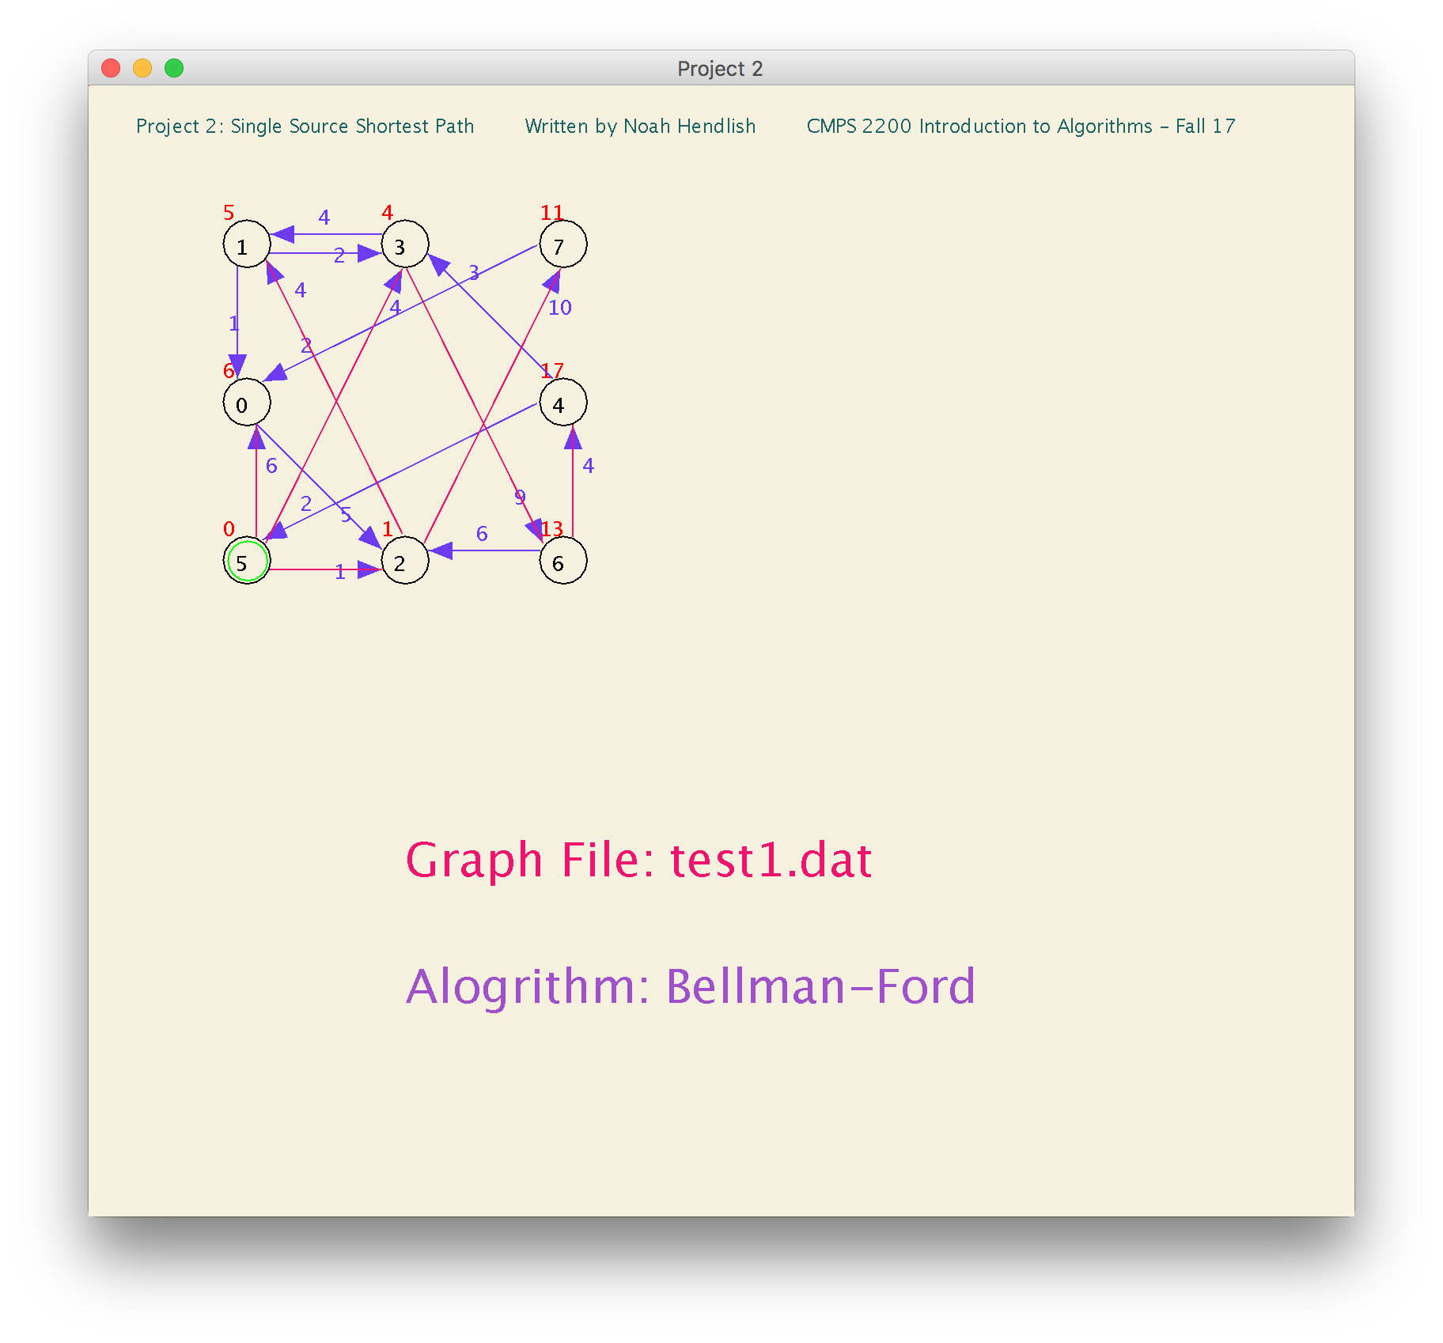

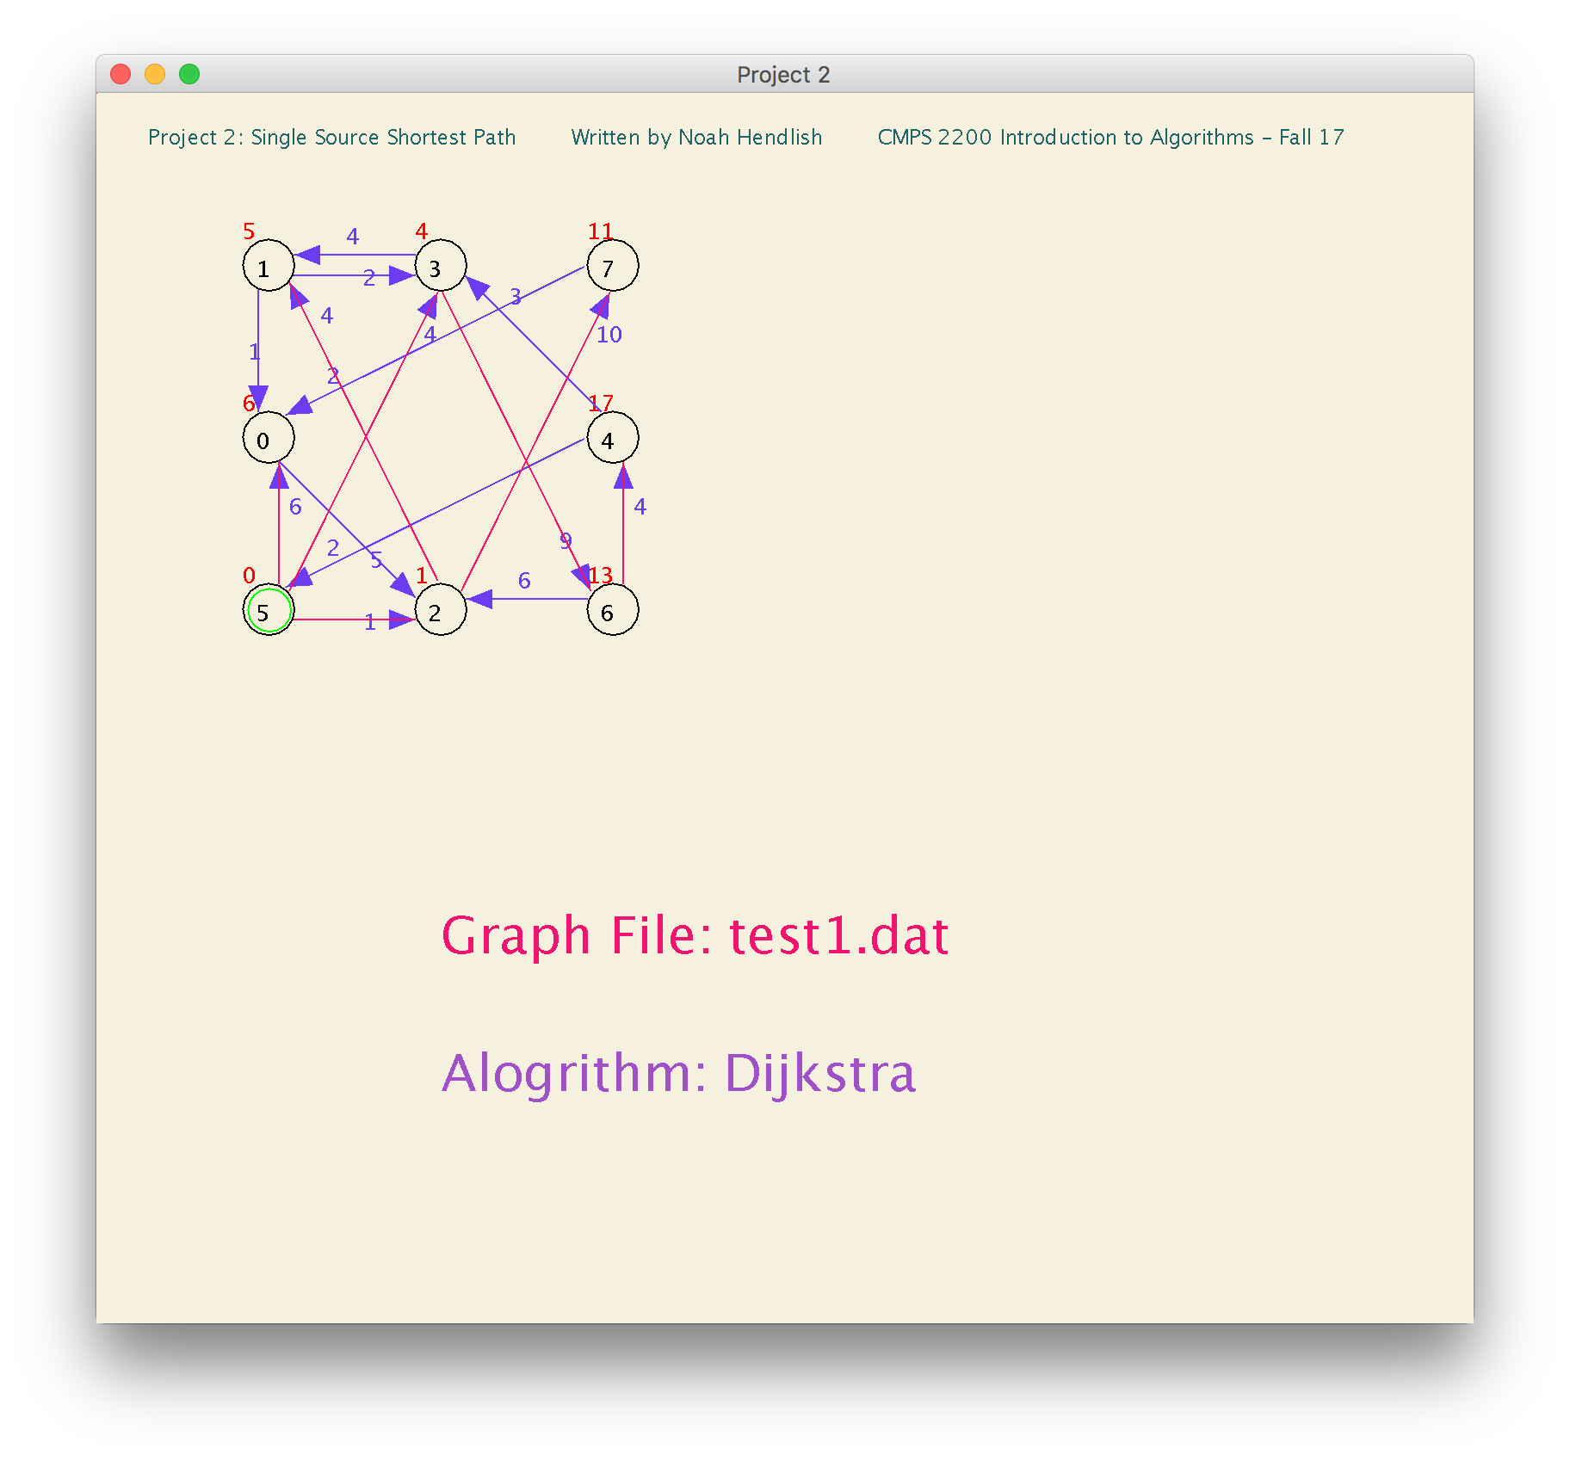

**Dijkstra on test1.dat (First Test Graph that I Created: Strongly Connected Graph)**

**Source Vertex ID: 7**

Graph does not contain any negatively weighted edges. All Edge weights positive. Dijkstra can find the shortest path.

**d-Values for Dijkstra on test1.dat**

Vertex: 0 1 2 3 4 5 6 7

d-Value: 2 11 7 13 26 28 22 0

**Predecessor Array for Dijkstra on test1.dat**

Vertex: 0 1 2 3 4 5 6 7

Predecessor: 7 2 0 1 6 4 3 -1

**Bellman-Ford on test1.dat (First Test Graph that I Created: Strongly Connected Graph)**

**Source Vertex ID: 7**

Graph does not contain any negative weight cycles.

**d-Values for Bellman-Ford on test1.dat**

Vertex: 0 1 2 3 4 5 6 7

d-Value: 2 11 7 13 26 28 22 0

**Predecessor Array for Bellman-Ford on test1.dat**

Vertex: 0 1 2 3 4 5 6 7

Predecessor: 7 2 0 1 6 4 3 -1

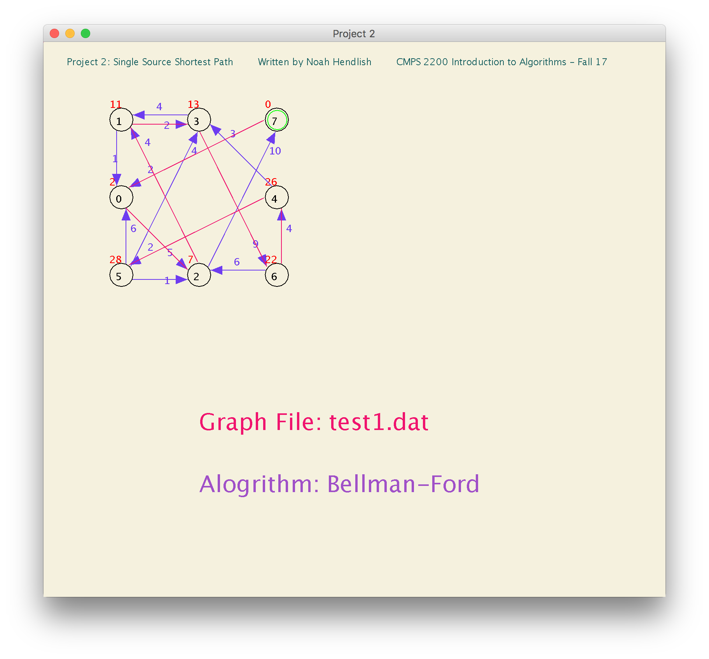

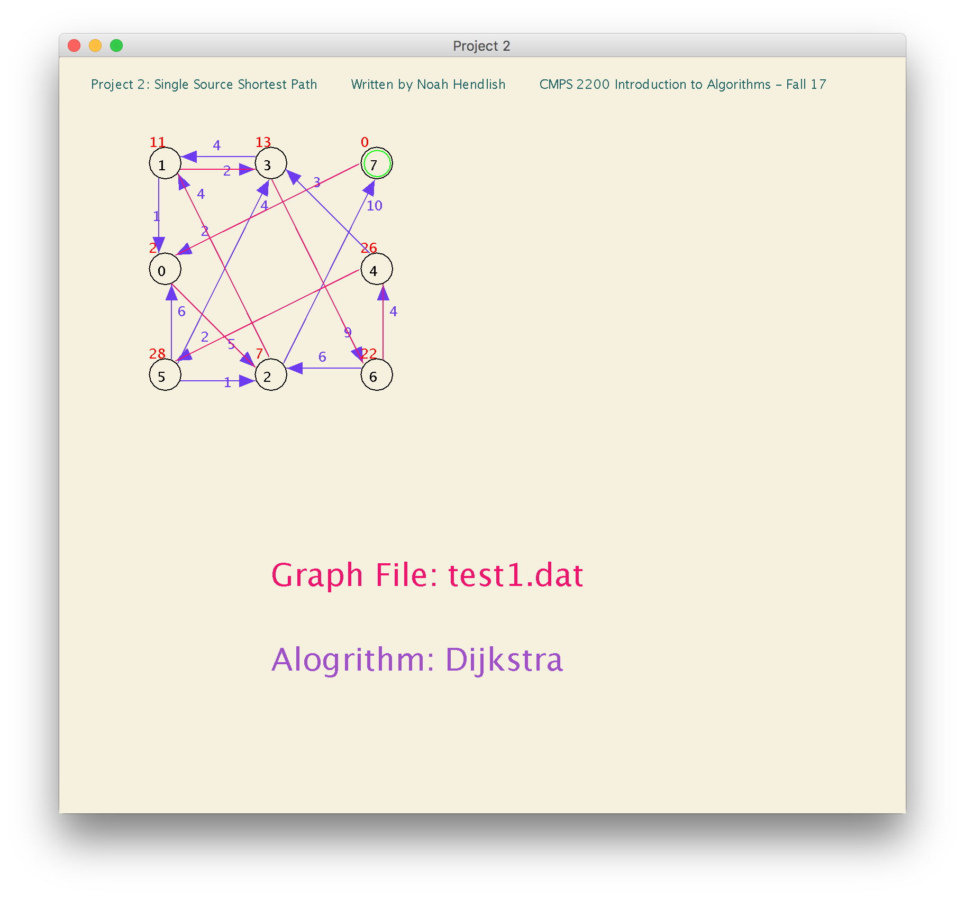

**Dijkstra on test1.dat (First Test Graph that I Created: Strongly Connected Graph)**

**Source Vertex ID: 1**

Graph does not contain any negatively weighted edges. All Edge weights positive. Dijkstra can find the shortest path.

**d-Values for Dijkstra on test1.dat**

Vertex: 0 1 2 3 4 5 6 7

d-Value: 1 0 6 2 15 17 11 16

**Predecessor Array for Dijkstra on test1.dat**

Vertex: 0 1 2 3 4 5 6 7

Predecessor: 1 -1 0 1 6 4 3 2

**Bellman-Ford on test1.dat (First Test Graph that I Created: Strongly Connected Graph)**

**Source Vertex ID: 1**

Graph does not contain any negative weight cycles.

**d-Values for Bellman-Ford on test1.dat**

Vertex: 0 1 2 3 4 5 6 7

d-Value: 1 0 6 2 15 17 11 16

**Predecessor Array for Bellman-Ford on test1.dat**

Vertex: 0 1 2 3 4 5 6 7

Predecessor: 1 -1 0 1 6 4 3 2

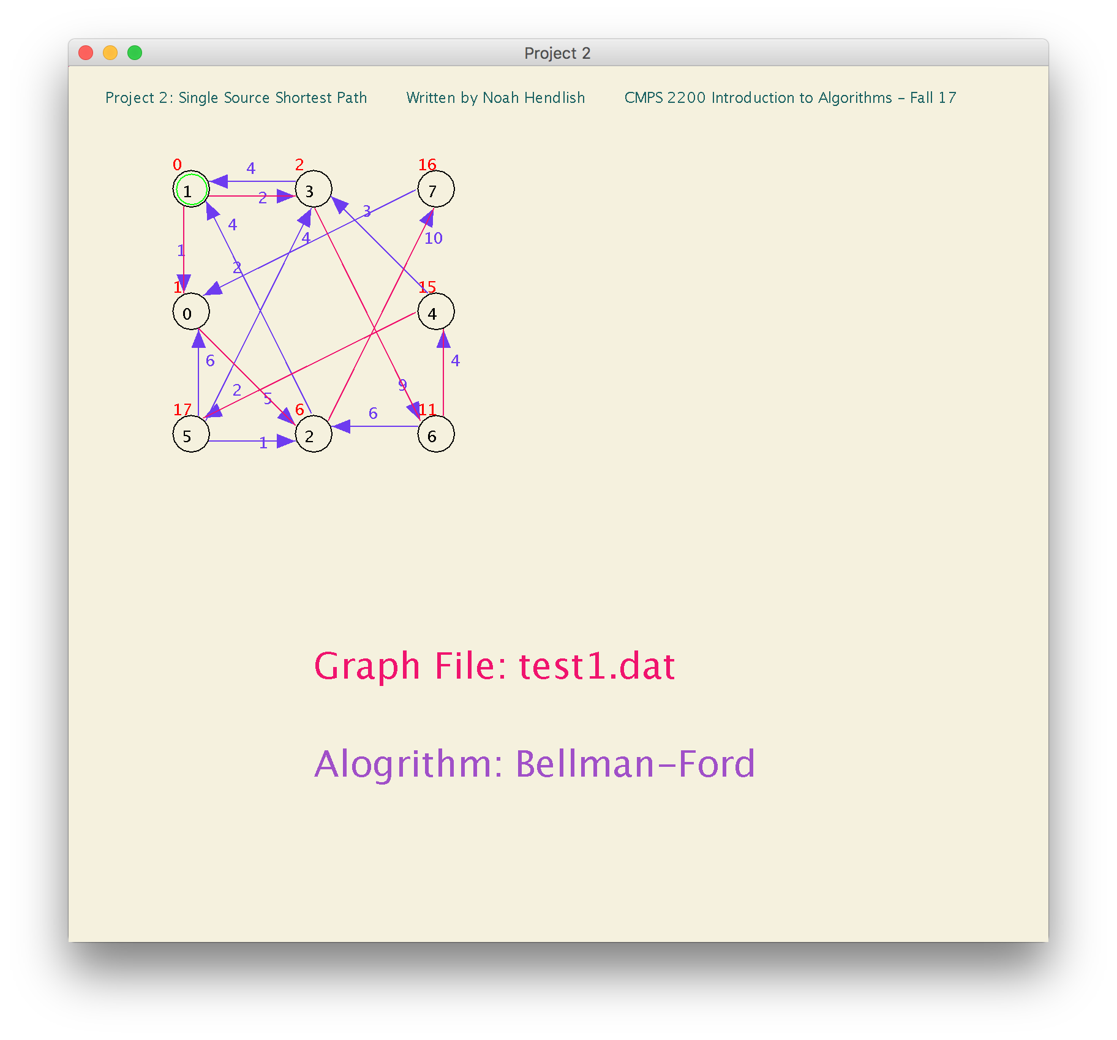

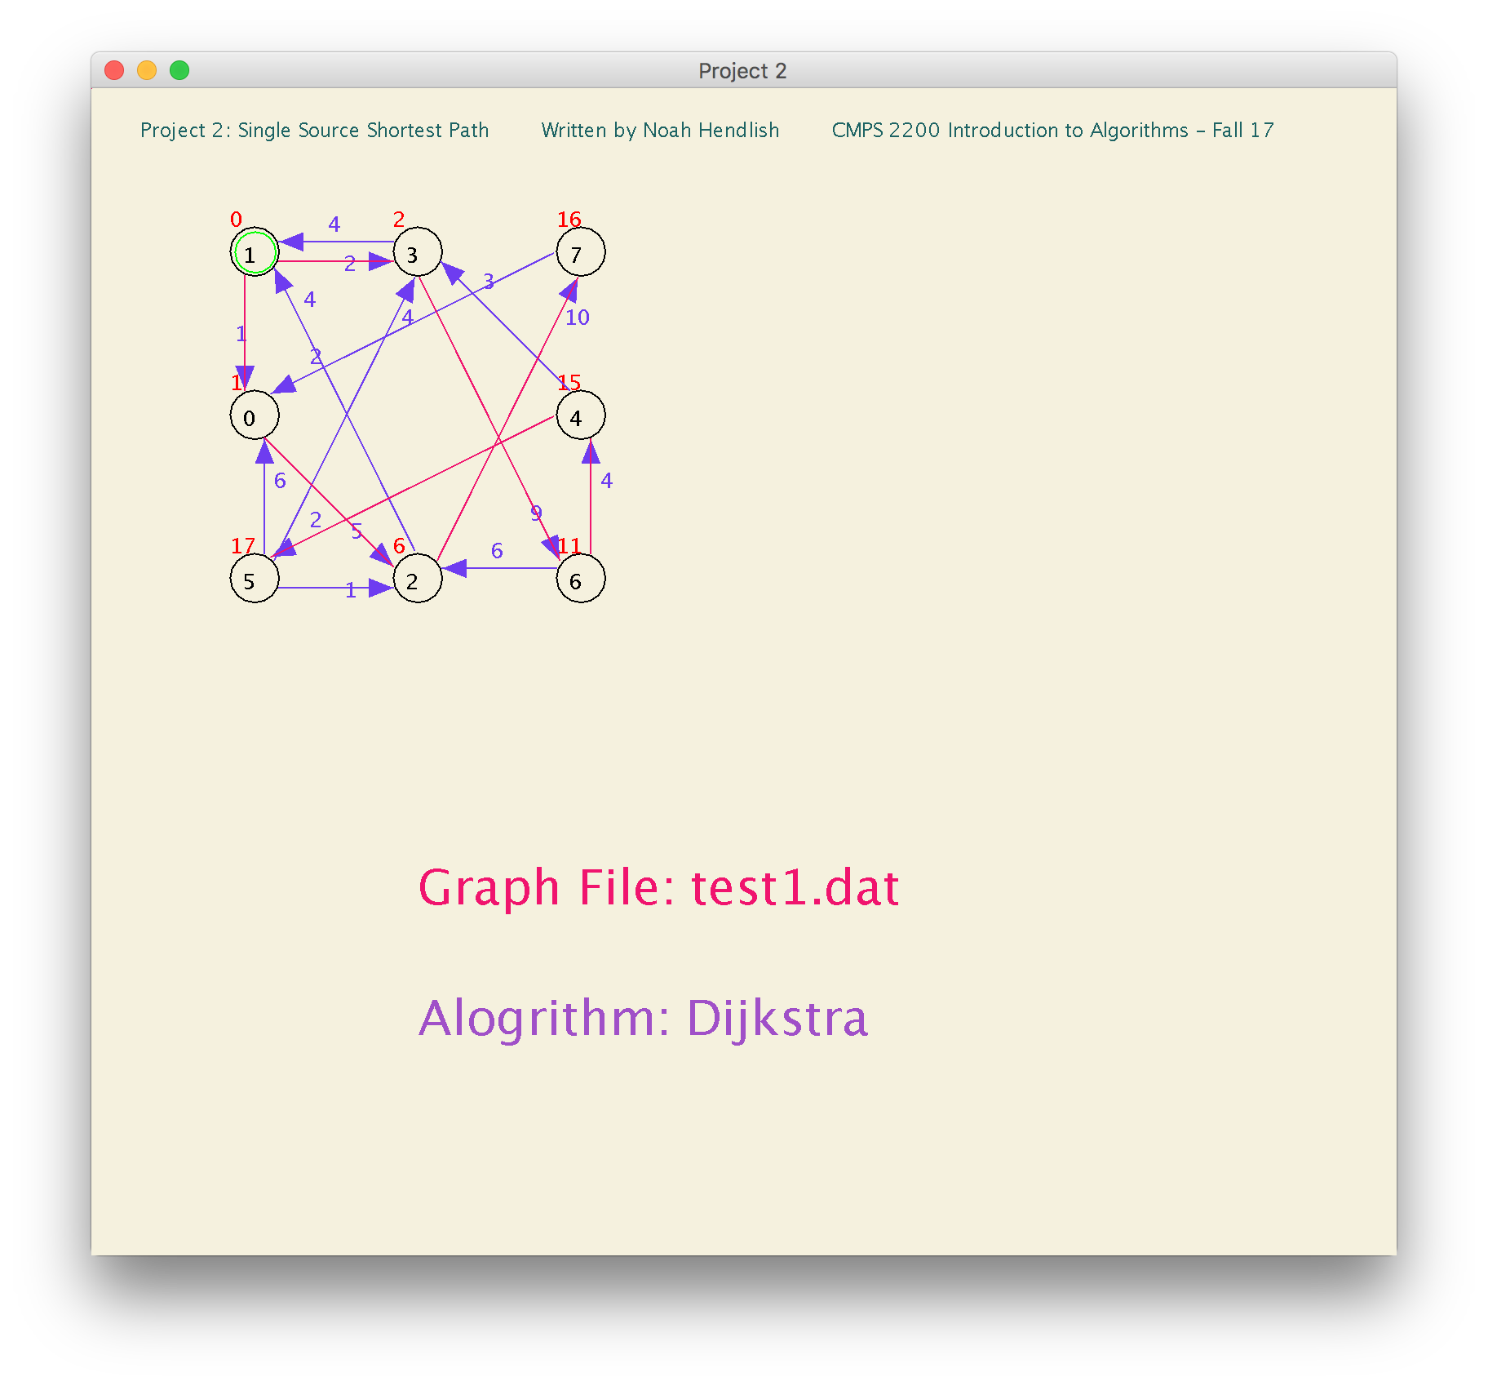

**Dijkstra on test2.dat (Second Test Graph that I Created: Strongly Connected Graph)**

**Source Vertex ID: 3**

**Vertex**: 0 1 2 3 4 5 6 7

**Predecessor**: 2 2 5 -1 6 3 5 6

**d-Value**: 11 11 8 0 13 7 11 12

**Bellman-Ford on test2.dat (Second Test Graph that I Created: Strongly Connected Graph)**

**Source Vertex ID: 3**

**Vertex**: 0 1 2 3 4 5 6 7

**Predecessor**: 2 2 5 -1 2 3 5 6

**d-Value**: 11 11 8 0 13 7 11 12

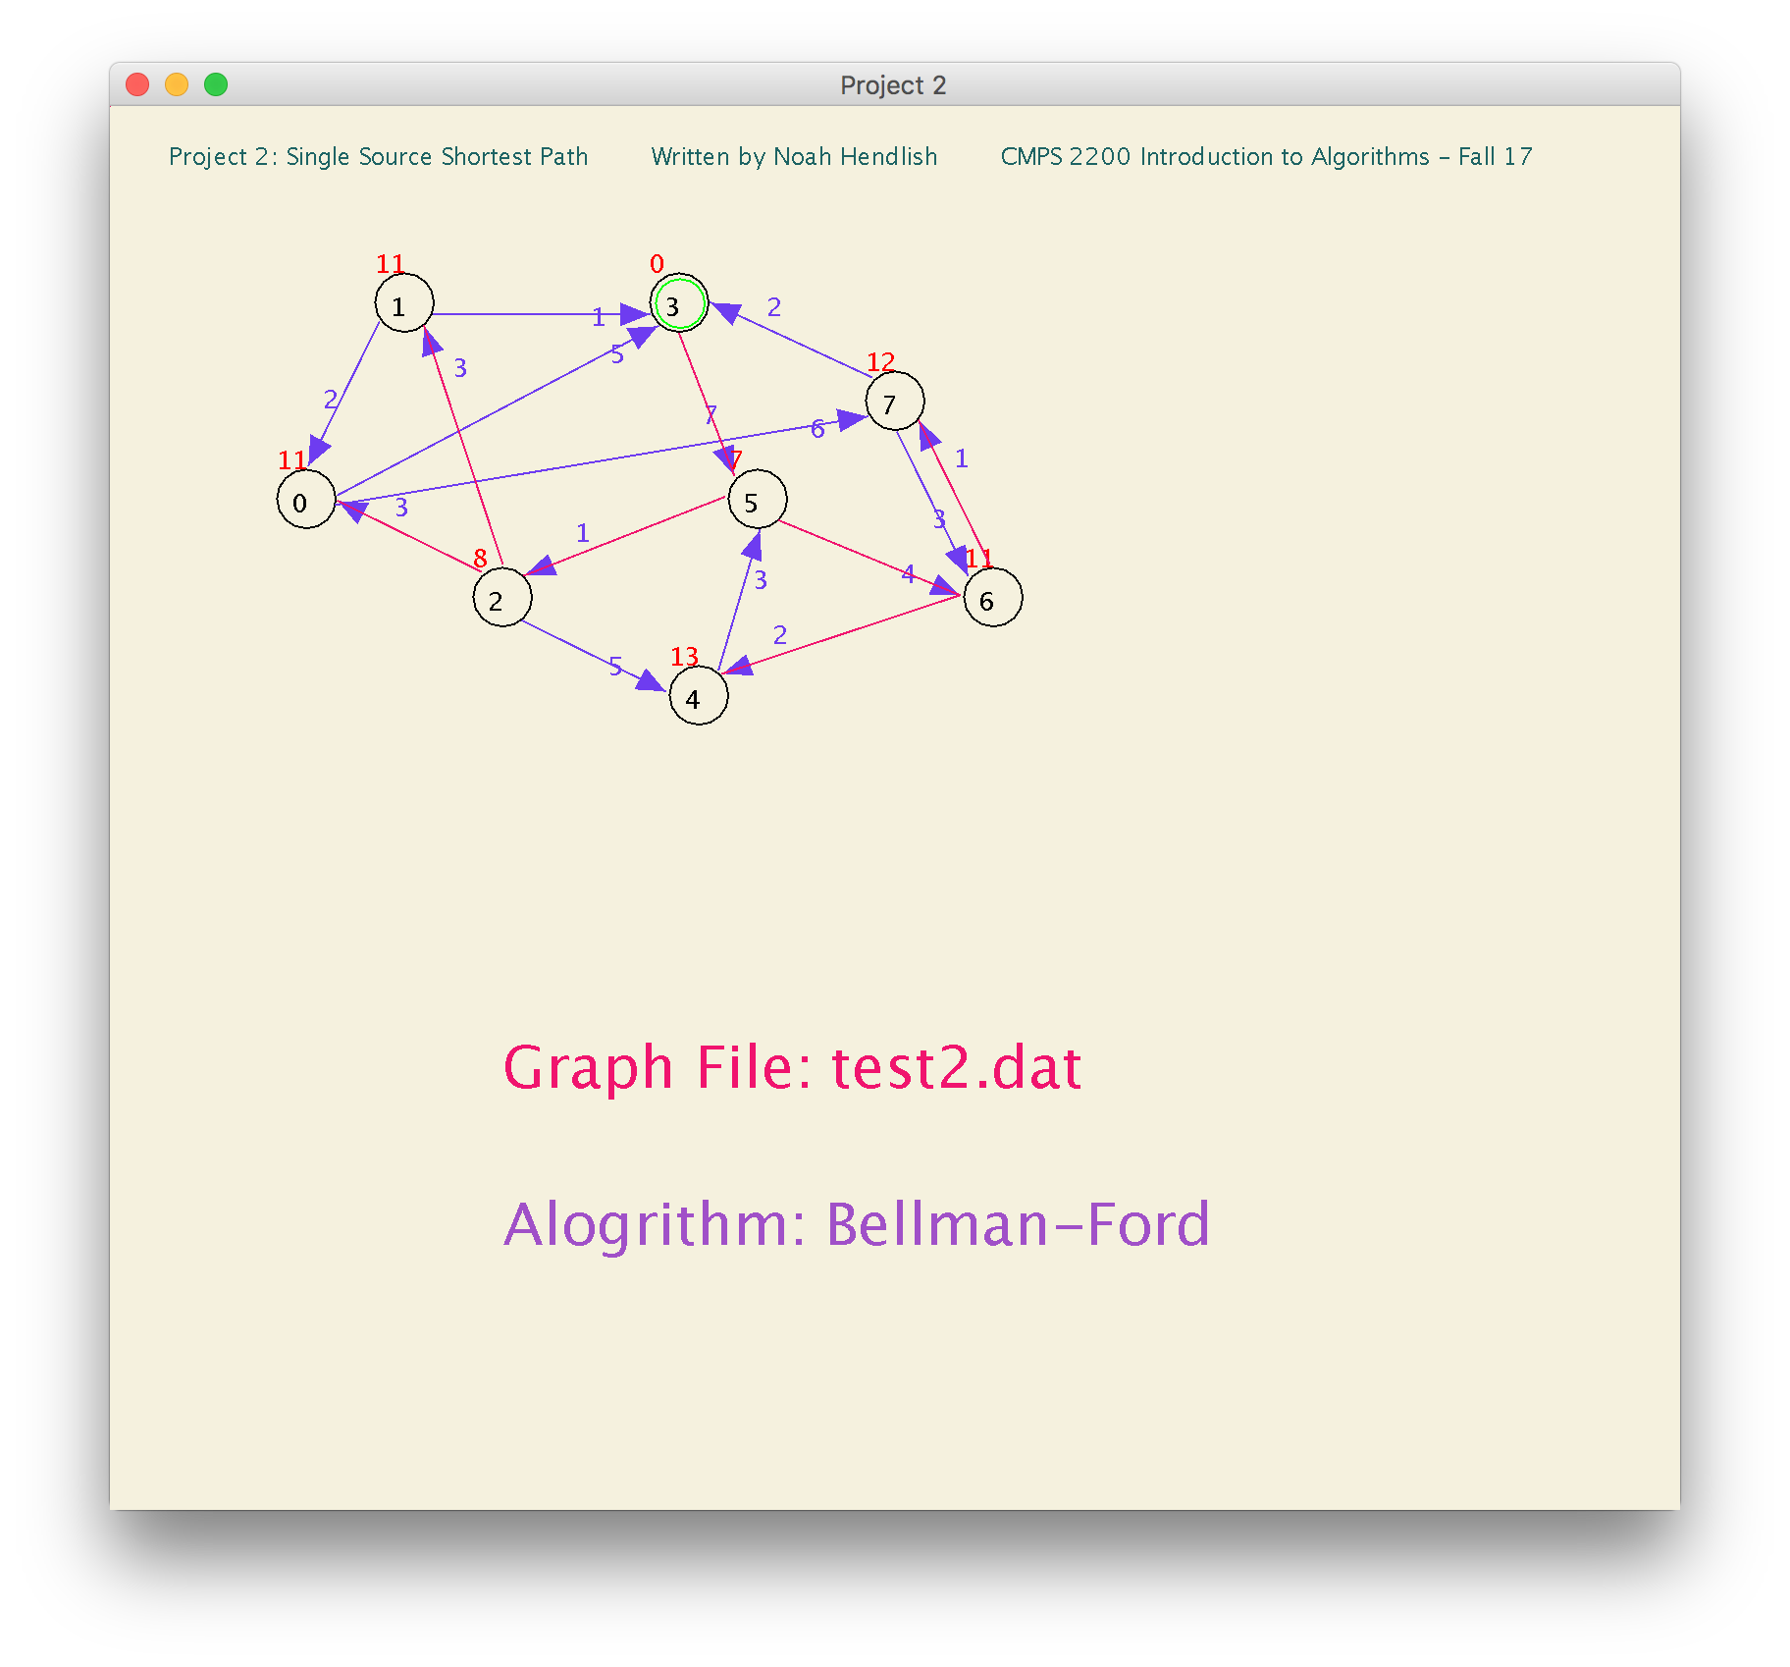

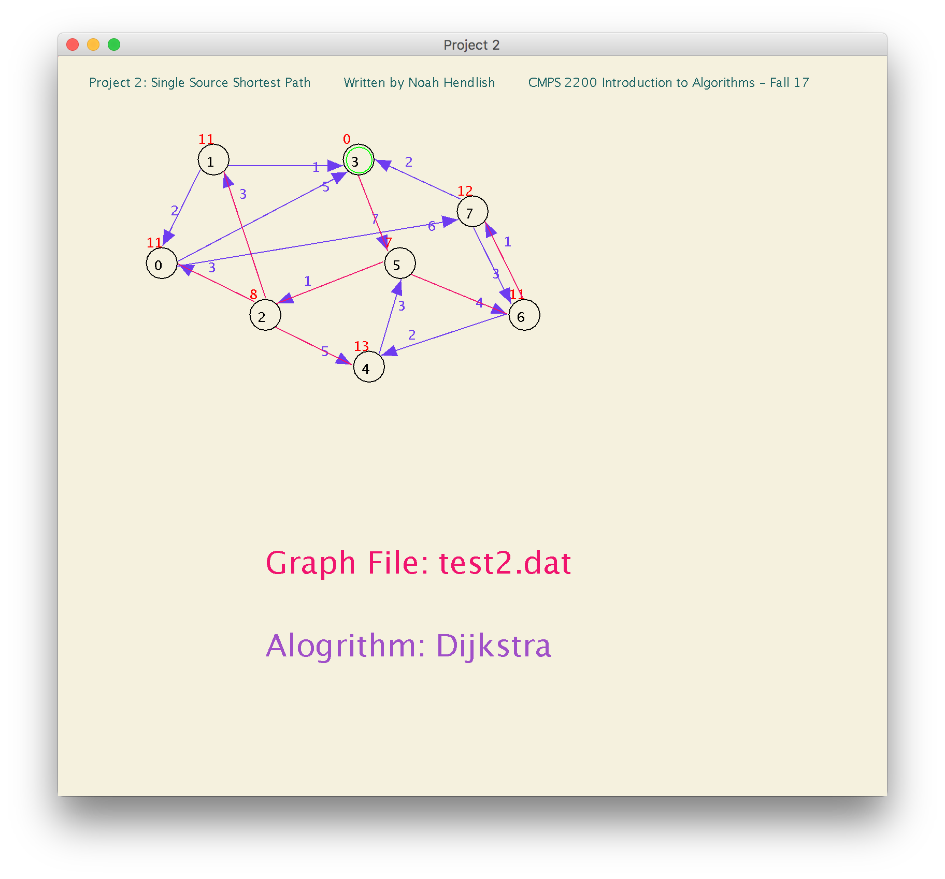

**Dijkstra on test2.dat (Second Test Graph that I Created: Strongly Connected Graph)**

**Source Vertex ID: 4**

**Vertex**: 0 1 2 3 4 5 6 7

Predecessor: 2 2 5 1 -1 4 5 6

d-Value: 7 7 4 8 0 3 7 8

**Bellman-Ford on test2.dat (Second Test Graph that I Created: Strongly Connected Graph)**

**Source Vertex ID: 4**

Vertex: 0 1 2 3 4 5 6 7

Predecessor: 2 2 5 1 -1 4 5 6

d-Value: 7 7 4 8 0 3 7 8

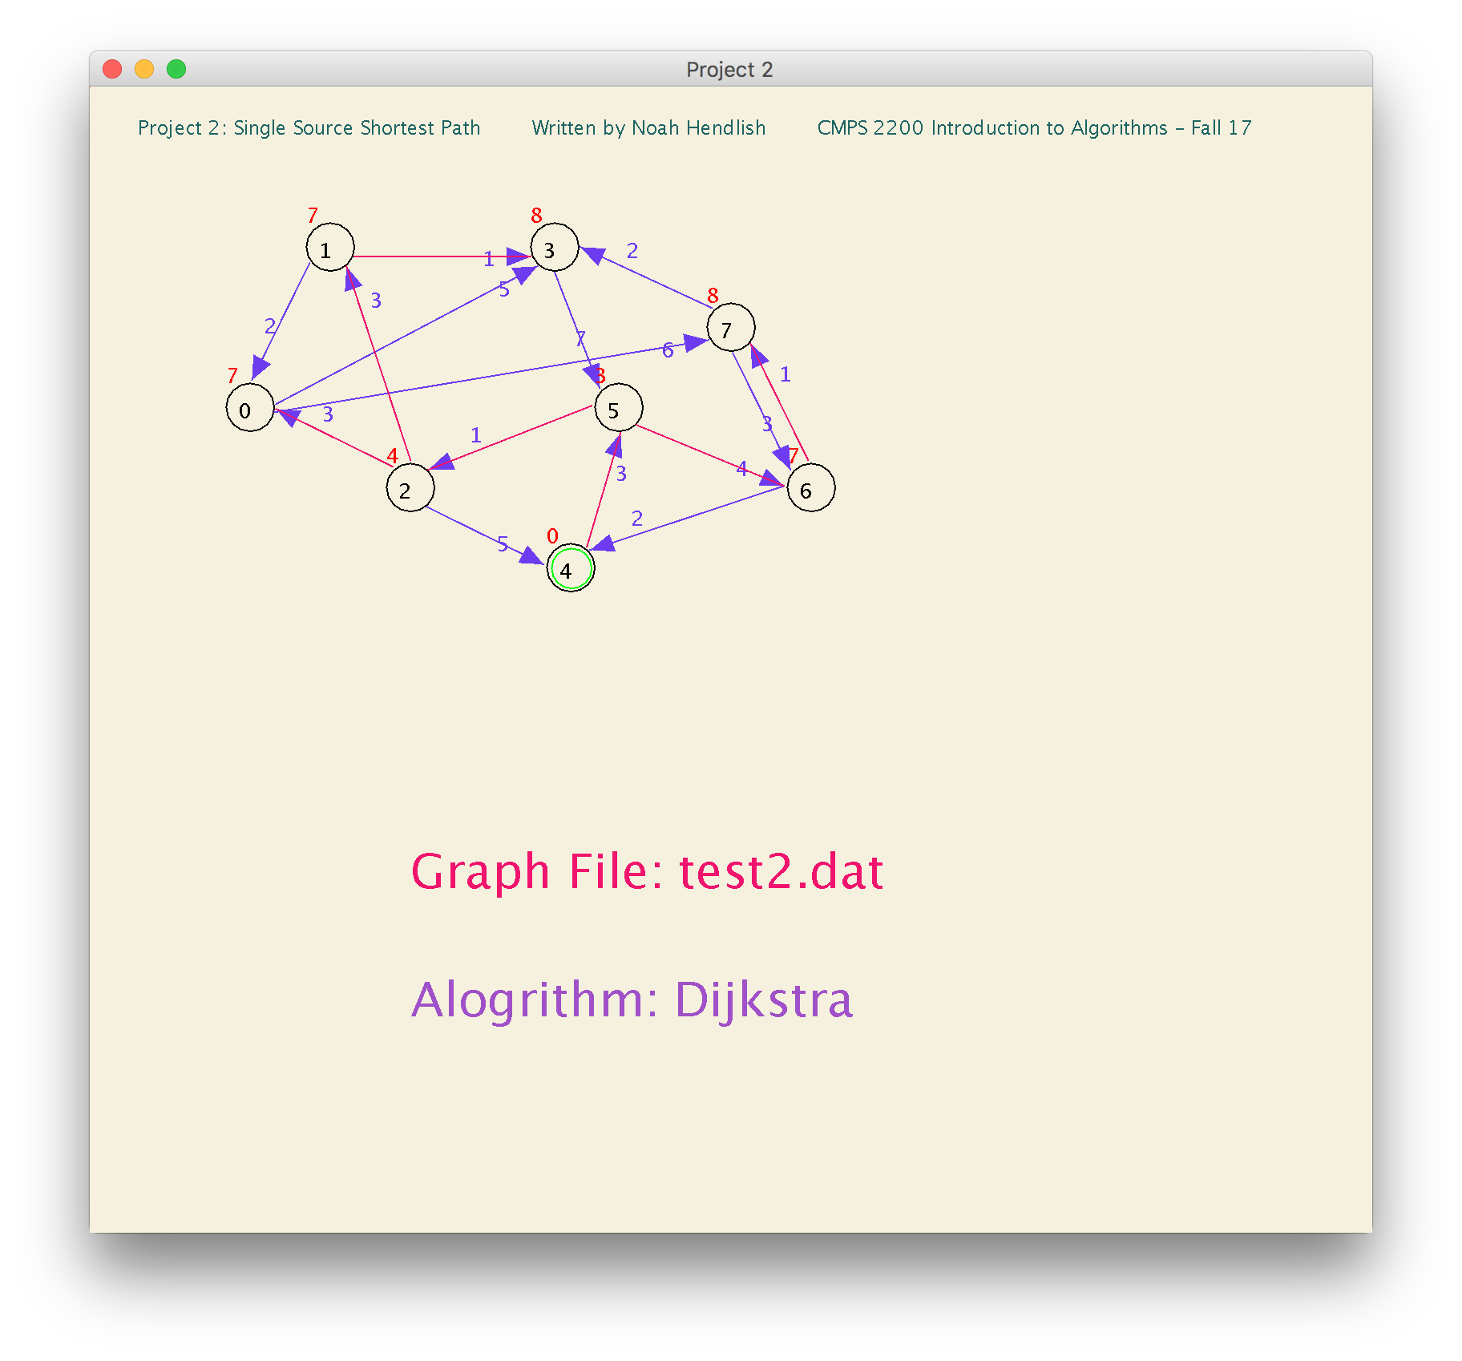

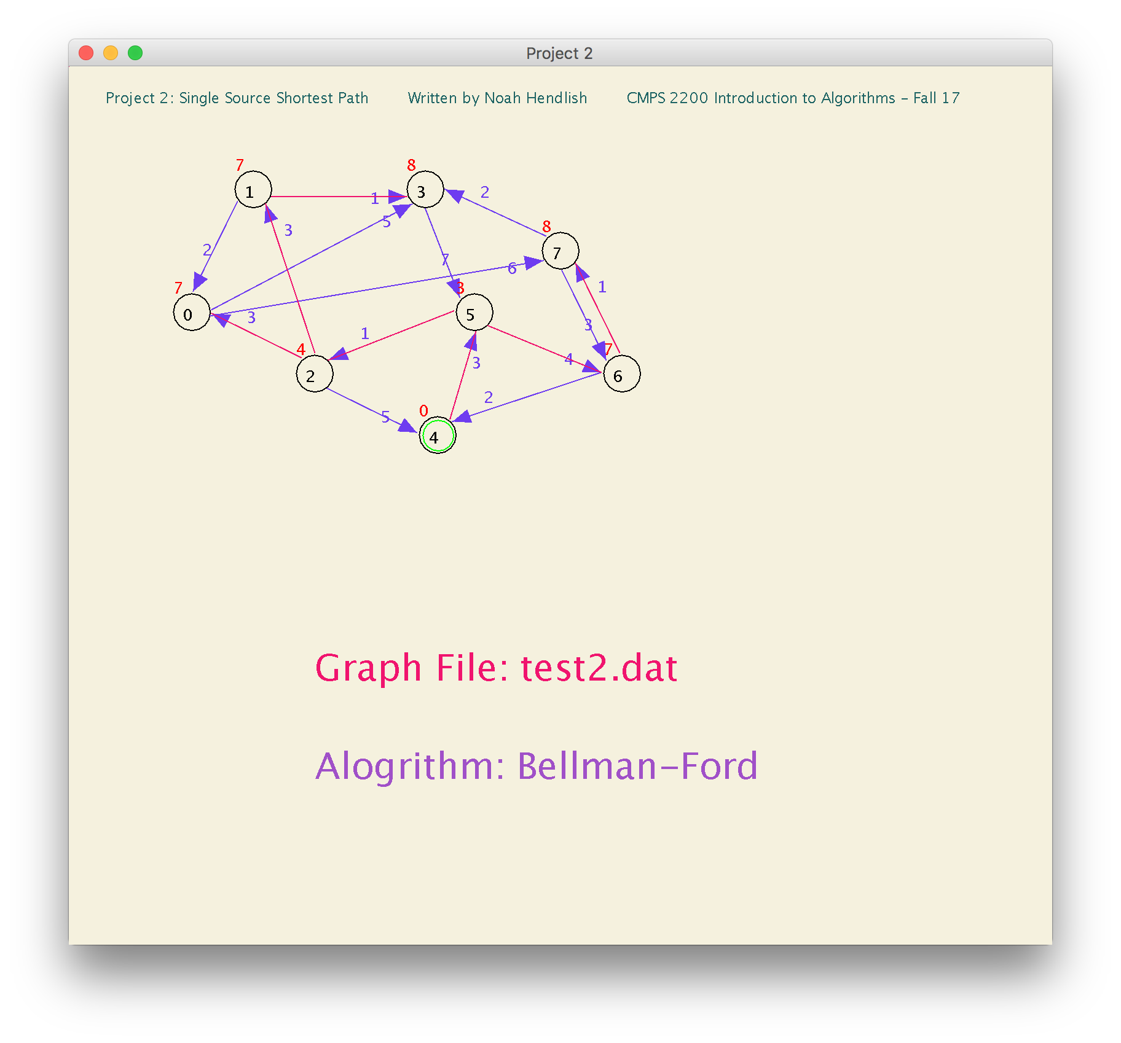

**Dijkstra on test2.dat (Second Test Graph that I Created: Strongly Connected Graph)**

**Source Vertex ID: 0**

Vertex: 0 1 2 3 4 5 6 7

Predecessor: -1 2 5 0 6 3 7 0

d-Value: 0 16 13 5 11 12 9 6

**Bellman-Ford on test2.dat (Second Test Graph that I Created: Strongly Connected Graph)**

**Source Vertex ID: 0**

Vertex: 0 1 2 3 4 5 6 7

Predecessor: -1 2 5 0 6 3 7 0

d-Value: 0 16 13 5 11 12 9 6

